Prepared by

Shankar Karthik
&
Anita

[Strictly Confidential]

Object Oriented Programming
There are many opinions of what it means for a development system or language to be "object oriented". However, it is widely agreed that any language that claims to be object oriented must at least support encapsulation, inheritance, polymorphism and dynamic binding.
http://www.eschertech.com/tutorial/tutorial1/oo_principles.htm

Encapsulation
Encapsulation means that the detailed implementation of a component is hidden from the rest of the system. Specifically, the data held by a component is normally not accessible from the outside of the component. Instead, a number of interface functions and procedures (collectively called methods) are provided for use by those parts of the software system that are clients (i.e. users) of the component.

The way most object oriented language support encapsulation is to allow the user to declare classes. A class is a collection of data variables (sometimes called attributes), private methods and public (or interface) methods, together with one or more special methods called constructors. A constructor for a class creates a new instance of the class (i.e. a new object with its own copies of the data variables). Instances can be stored in variables, passed as parameters, etc. but the data within an instance cannot be directly accessed. Instead, the interface methods of the class can be invoked on the particular instance to modify the values of the data variables and/or return information about them.

Questions
What do we gain by encapsulation?
http://www.brpreiss.com/books/opus4/html/page14.html
Conceptual Independence – User of an Object can do anything he wants without depending on the object or changes to the object. Common in Procedural Language defining a module.
Physical Independence – The behavior of the Object is defined entirely by it and cannot be changed by external entity.

How is it different from C or Procedural Language
Procedural Programming separates the data of the program from the operations that manipulate the data. For example, if you want to send information across a network, only the relevant data is sent, with the expectation that the program at the other end of the network pipe knows what to do with it. In other words, some sort of handshaking agreement must be in place between the client and server to transmit the data. In this model, no code is actually sent over the wire.
Eg: Data transmitted over a wire
OO programming - The fundamental advantage of OO programming is that the data and the operations that manipulate the data (the code) are both encapsulated in the object. For example, when an object is transported across a network, the entire object, including the data and behavior, goes with it. Eg an Employee object is sent over the network.
A good example of this concept is a Web object, such as a Java applet. The browser has no idea of what the Web object will do. When the object is loaded, the browser executes the code within the object and uses the data contained within the object.

Inheritence [= Reuse]

- Inheritance is a facility to declare new classes by extending old ones.
- Inheritence is a way to relate 2 objects.

Polymorphism [= Reuse]
Polymorphism ("many structures") is a facility by which one type can be substituted for another.

Dynamic Binding
Dynamic binding means that where you are using polymorphism and you call a method, the "version" of the method that actually gets called depends on the actual type(s) of the instance(s) involved. For example, suppose you declared BankAccount and then SavingsAccount, but in declaring SavingsAccount you redefined the inherited method withdraw. This gives you two versions of withdraw. Then, each time a call is made to myAccount.withdraw(someMoney), the version of withdraw that is called will depend on whether myAccount holds a plain BankAccount, or a SavingsAccount.

Basic Java

General Java

Is null a valid reference?
Yes.

When is a Class Abstract?
Any class declared with abstract key word. Beware it cannot be final. But if it has an abstract method it should be declared abstract.

ConcreteD → AbstractC → ConcreteB → ConcreteA
Yes this is possible

Why one favors Interface over Inheritence? Why multiple inheritances are not allowed in Java?
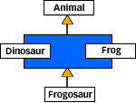

- Reason1 : Diamond class problem : Interfaces promote more polymorphism, enables composition, flexibility, use it for unrelated objects.
- Reason 2: Inheritance breaks Encapsulation If super class changes all subclasses have to be recompiled.

Explain Arrays in Java?
Legal constructions:

int []a1[];
int [][]a2;
int a3[][];
int[] a4[];
[]int a5;→ NOT LEGAL

Explain final, finally and finalize?
final | is a non-access modifier. A final class cannot be extended. A final method cannot be overridden when its class is inherited. The value of a final variable cannot be changed. Its one interesting use is in anonymous classes and inner classes.  http://renaud.waldura.com/doc/java/final-keyword.shtml  Remember there are only final references not final objects.  final methods are helpful in method inlining and improving performance.
finally | No matter what happens [a call to return, throw an exception] finally is called – except for System.exit(1).
finalize | finalize() is a method provided by Java in java.lang.Object as a protected method which can be used to run some code just before your object is deleted by the garbage collector. On the surface this sounds like a great idea; maybe your object opened up some resources, and you’d like to close them before your object is deleted. The problem is that, as you may have gathered by now, you can’t count on the garbage collector to ever delete an object. So, any code that you put into your class’s overridden finalize() method is not guaranteed to run. The finalize() method for any given object might run, but you can’t count on it, so don’t put any essential code into your finalize() method. It is also run one and only once.  OBJECT RESURRECTION: assign the object reference to a static field. But this can be resurrected only once

Usage of final in formal parameters and inner classes?
Making parameters as final is a considered as a good practice as the called method shouldn’t change the values. Inner classes can use only final variables, as during compile time it could be in-lined with the class.

Polymorphism in Java?
http://www.javaworld.com/javaworld/jw-04-2001/jw-0413-polymorph.html?page=1

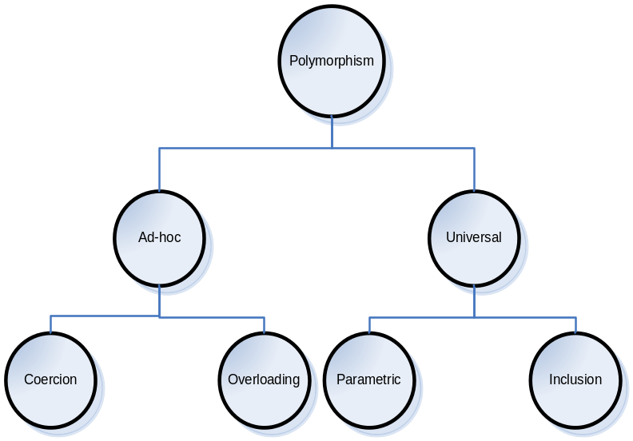
Coercion | - Represents implicit parameter type conversion to the type expected by a method or an operator, thereby avoiding type errors.  Eg 1:  2.0 + 2.0  2.0 + 2  2.0 + “2”  Eg 2:  Another example is from Expression Language [EL] used in JSP Tags  ${musicList[2]} is same as ${musicList[“2”]}  here “2” String is co-erced to int 2
Overloading | - Permits the use of same operator or method name to denote multiple distinct program meanings.  Eg:  + operator used above  Overloading of method names.
Parametric | - Parametric polymorphism allows the use of a single abstraction across many types. For example, a List abstraction, representing a list of homogeneous objects, could be provided as a generic module.  - You would reuse the abstraction by specifying the types of objects contained in the list. Since the parameterized type can be any user-defined data type, there are a potentially infinite number of uses for the generic abstraction, making this arguably the most powerful type of polymorphism.  Eg:  Generics in 1.5
Inclusion | - Inclusion polymorphism achieves polymorphic behavior through an inclusion relation between types or sets of values. For many object-oriented languages, including Java, the inclusion relation is a subtype relation. So in Java, inclusion polymorphism is subtype polymorphism.  - When Java developers generically refer to polymorphism, they invariably mean subtype polymorphism. Gaining a solid appreciation of subtype polymorphism's power requires viewing the mechanisms yielding polymorphic behavior from a type-oriented perspective. The rest of this article examines that perspective closely. For brevity and clarity, I use the term polymorphism to mean subtype polymorphism.

http://www.javaworld.com/javaworld/jw-04-2001/jw-0413-polymorph.html?
http://research.microsoft.com/Users/luca/Papers/OnUnderstanding.pdf

Interface VS Class in Java - Thoughts
Types [Interfaces] determine what methods the object may perform
Implementation [Classes] determines how the object actually responds to each method.

That is, types declare responsibilities, and classes implement those responsibilities. By cleanly separating type and implementation, we find the two governing a grand object dance: types determine permissible partners and the names of the dances, while implementations choreograph the actual steps.

The concept of type best captures the spirit of freeing object interactions from the details of object implementation. Rather than refer to the interface of an object, a type-oriented perspective encourages referring to the reference type attached to an object. The reference type dictates the permissible interaction with the object. Think type when you want to know what an object can do, as opposed to how the object implements its responsibilities.

http://www.javaworld.com/javaworld/jw-04-2001/jw-0413-polymorph.html?page=6

Class inheritance through the Java extends clause further facilitates modularization. Module, or implementation, inheritance offers a way to create subclasses that automatically utilize implementation code from the super class module. Subclasses build on super class implementation and thus provide a means for module extension. This implementation-centric view of inheritance emphasizes code reuse.

Java classes also play an additional significant role. As well as providing implementation code, every class also defines a type. We often speak of this type as the public interface to the class. That terminology is somewhat confusing in light of the Java language interface keyword. Regardless, the set of public methods declared by the class defines a new type. This new type enjoys all the privileges and benefits of the Java type system in a manner that is completely independent of implementation code. Whether concrete or abstract, a class always defines a single new type.

Inheritance via the extends clause also plays another important role that mirrors a class's ability to define a type. Type, or interface, inheritance provides a mechanism for creating subtypes that build on a super-type's public interface. Since a type B declared as a subtype of A also has type A, the type-checker permits any variable or program expression of type B when expecting a variable or program expression of type A.
Curiously, Java interfaces offer perhaps the clearest distinction between type and class. An interface, quite simply, declares a type, deferring partial or full implementation to abstract or concrete classes. At first glance, that may seem to be the same as a class with no implementation. In fact, Java interfaces are often compared to C++ pure abstract classes. That misguided comparison, however, clouds an important Java language contribution. An interface not only separates type declaration from module implementation, it also facilitates the separation of type inheritance and implementation inheritance.

http://www.javaworld.com/javaworld/jw-01-2001/jw-0119-type.html

Differentiate Overloading and Overriding?
Abstract methods must be overridden by the first concrete (non-abstract) subclass. With respect to the method it overrides, the overriding method.
{public} {void} overrideMe({args_list}) throws {Exception}
- Must have the same argument list
- Must have the same return type
- Must not have a more restrictive access modifier
- May have a less restrictive access modifier
- Must not throw new or broader checked exceptions
- May throw fewer or narrower checked exceptions, or any unchecked exception
- Final methods cannot be overridden.
- Only inherited methods may be overridden.
- A subclass uses superClass.overriddenMethodName() to call the superClass version of an overridden method.
Overloading means reusing the same method name, but with different arguments. Overloaded methods
- Must have different argument lists.
- May have different return types, as long as the argument lists are also different
- May have different access modifiers
- May throw different exceptions.
- Methods from a super-class can be overloaded in a subclass.

Polymorphism applies to overriding, not to overloading - Nope
Object type determines which overridden method is used at runtime.
Reference type determines which overloaded method will be used at compile time.

Explain Runtime and Compile time polymorphism
Compile time polymorphism is functions and operators overloading. Runtime time polymorphism is done using inheritance [Class and Interface]

java.lang.Object

Default implementation of equals() ?
Default in Class Object uses object identity i.e., uses == operator for comparison

Default implementation of hashCode() ?
The default implementation of hashCode() provided by Object is derived by mapping the memory address of the object to an integer value. Because on some architectures the address space is larger than the range of values for int, it is possible that two distinct objects could have the same hashCode(). If you override hashCode(), you can still use the System.identityHashCode() method to access this default value.

What is the need for implementing equals() and hashCode()?
- Default in Class Object uses object identity i.e., uses == operator for comparison
- Compares two objects in Same Heap Remember equals() compares two objects in the same heap. That is why EJBObject provides isIdentical() to compare two remote objects.
- Should be Idempotent when comparison : Eg: URL vs URI equals() in URI is dependent on Environment and is not idempotent
http://brian.pontarelli.com/2006/12/05/mr-gosling-why-did-you-make-url-equals-suck/

What objects qualify for a Key in HashMap?

Why should you override hashCode() when equals is sufficient from comparing two objects?
http://www-128.ibm.com/developerworks/java/library/j-jtp05273.html

What would happen if Integer did not override equals() and hashCode() ?. Nothing, if we never used an Integer as a key in a HashMap or other hash-based collection. However, if we were to use such an Integer object for a key in a HashMap, we would not be able to reliably retrieve the associated value, unless we used the exact same Integer instance in the get() call as we did in the put() call. This would require ensuring that we only use a single instance of the Integer object corresponding to a particular integer value throughout our program. Needless to say, this approach would be inconvenient and error prone.

The interface contract for Object requires that if two objects are equal according to equals() , then they must have the same hashCode() value. Why does our root object class need hashCode(), when its discriminating ability is entirely subsumed by that of equals()? The hashCode(),method exists purely for efficiency. The Java platform architects anticipated the importance of hash-based collection classes -- such as Hashtable, HashMap, and HashSet -- in typical Java applications, and comparing against many objects with equals()can be computationally expensive. Having every Java object support hashCode() allows for efficient storage and retrieval using hash-based collections.

Two equal objects must have the same hashCode(), but its reverse it not true. Why?
- Symmetry: For two references, a and b, a.equals(b) if and only if b.equals(a)
- Reflexivity: For all non-null references, a.equals(a)
- Transitivity: If a.equals(b) and b.equals(c), then a.equals(c)
- Consistency with hashCode(): Two equal objects must have the same hashCode() value

Collections

Collections
In mathematics, a map is just a collection of pairs. In the Collections Framework, however, the interfaces Map and Collection are distinct with no lineage in the hierarchy. The reasons for this distinction have to do with the ways that Set and Map are used in the Java technology libraries. The typical application of a Map is to provide access to values stored by keys. The set of collection operations are all there, but you work with a key-value pair, instead of an isolated element. Map is therefore designed to support the basic operations of get() and put() which are not required by Set.
java.util.Collection
java.util.Map

java.util.List
java.util.Set

List Lists of things
ArrayList | Growable Array. Fast iteration and fast random access.
Vector | Same as ArrayList but synchronized for thread safety.
LinkedList | Ordered by index positions.  Random Access O(1) access time
Set Unique things
HashSet | Uses hashCode()  More efficient our implementation more performance  Allows null
LinkedHashSet | Ordered HashSet. Use this if you care about iteration order as it iterates using the order with which elements are inserted.
TreeSet | Sorted Collection based on Natural Order [Ascending]
Map Things with a unique ID
HashMap | Unordered and Unsorted.  Allows one Null key and multiple Null values in a collection.
Hashtable | Synchronized HashMap. By synchronized only methods are synchronized not/never the class itself.  Unlike HashMap it doesn’t allow anything that is null.
LinkedHashMap | Maintains insertion order.
TreeMap | Sorted Map.  Red Black Trees  Map is sorted on natural order based on Keys

Significance of Keys stored in HashMap and Hashtable
http://www.ibm.com/developerworks/java/library/j-jtp02183.html
Some mutable objects will change their hashCode() value depending on their state (like the StringHolder example class in Listing 2). If you use such a mutable object as a HashSet key, and then the object changes its state, the HashSet implementation will become confused - the object will still be present if you enumerate the set, but it may not appear to be present if you query the set with contains(). Needless to say, this could cause some confusing behavior.

HashMap VS Hashtable?
Hashtable is a legacy classs and extends java.util.Dictionary
You can put n number of null keys to a HashMap. As hash means unique it takes only one name value pair.
HashMap | Hashtable
Non-Synchronized | Synchronized
Can accept null values and only one null Key | Nope

What is a Vector? How is data stored in it?
- Vector’s methods are synchronized, ArrayList’s are not. This means that Vector is threadsafe, at some extra cost.
- The collection framework provides an alternative to ArrayList called LinkedList, which offers different performance tradeoffs.
- When Vector needs to grow its internal data structure to hold more elements, the size of the structure is doubled, whereas for ArrayList, the size is increased by 50%. So ArrayList is moreconservative in its use of space.
- It’s worth using the collection framework in your applications if you possibly can, because it’s now the "standard" way to handle collections. If you are concerned about thread safety, one way to handle this issue is to use wrappers around objects like ArrayList, for example: List list = Collections.synchronizedList(new ArrayList());

Many programmers find it odd that arrays have a different syntax than do most objects. Others find it inconvenient that arrays have a fixed size. To handle these, and similar, objects, Java provides an array-like structure called java.util.Vector. Vectors are much like arrays in that Vectors are
- Homogeneous - vectors typically store only one kind of element;
- Indexed - vectors permit clients to access values using integers that indicate position;
- Efficient - vectors provide fast access to values.
- All methods are synchronized

Compare Array, ArrayList and LinkedList
An ArrayList is better than Array to use when you have no knowledge in advance about elements number. ArrayList are slower than arrays. So, if you need efficiency try to use ArrayS if possible.

Short Overview on main features of ArrayList:

- The add operation runs O(n) time.
- The isEmpty, size, iterator, set, get and listIterator operations require the same amount of time, independently of element you access.
- Only Objects can be added to an ArrayList not primitive types like Arrays
- Implements all methods from the List interface
- Permits null elements

An ArrayList could be a good choice if you need very flexible Array type of collection with limited functionality.
Note: One small remark for those who needs faster ArrayList. ArrayList internally implemented as an Array. So when run an "add" command a new Array will be created with n+1 dimension. All "older" elements will be copied to first n elements and last n+1 one will filled with the value which you provide with add() method. To avoid that internal re-copying of arrays you should use ArrayList.ensureCapacity(int requestCapacity) method - it will create an array only once.

If you have higher requirements on number of accessible methods for your Array like collection instead of ArrayList you have better choice - LinkedList.

LinkedList is much more flexible and lets you insert, add and remove elements from both sides of your collection - it can be used as queue and even double-ended queue!
Vector vs ArrayList
- Vector’s methods are synchronized, ArrayListS are not. This means that Vector is threadsafe, at some extra cost.
- The collection framework provides an alternative to ArrayList called LinkedList , which offers different performance tradeoffs.
- When Vector needs to grow its internal data structure to hold more elements, the size of the structure is doubled, whereas for ArrayList, the size is increased by 50%. So ArrayList is more conservative in its use of space.
- It’s worth using the collection framework in your applications if you possibly can, because it’s now the "standard" way to handle collections. If you are concerned about thread safety, one way to handle this issue is to use wrappers around objects like ArrayList , for example: List list = Collections.synchronizedList(new ArrayList());
- ArrayList.ensureCapacity() → setting this to a predefined value stops ArrayList to grow dynamically every time during an ArrayList.add()operation
- ArrayList vs LinkedList – Adding elements in ArrayList is expensive compared to LinkedList. Whereas Retrieving elements from an ArrayList is very cheap when compared to LinkedList.

What data structure you will use for building least recently used cache?
Use a LinkedHashSet which maintains the order in which the elements are last accessed, rather than the order in which they are inserted.

What is identity HashMap?
This class is not a general-purpose Map implementation! While this class implements the Map interface, it intentionally violates Map's general contract, which mandates the use of the equals() method when comparing objects. This class is designed for use only in the rare cases wherein reference-equality semantics are required.

Why is Map an interface instead of a Class?
http://tiedyedfreaks.org/eric/CompositionVsInheritance.html

First Interfaces give much more polymorphism.
Provides Late Binding of Implementation by Object Composition.

public class NoCaseHashMap extends HashMap {  private String toKey(Object key) {  if (key == null) {  return null;  }  return key.toString().toLowerCase();  }  public Object get(Object key) {  return super.get(toKey(key));  }  public Object put(Object key, Object value) {  return super.put(toKey(key), value);  }  public boolean containsKey(Object key) {  return super.containsKey(toKey(key));  }  public Object remove(Object key) {  return super.remove(toKey(key));  }  } | public class NoCaseMap implements Map {  private Map map;  public NoCaseMap(Map map) {  this.map = map;  }  private String toKey(Object key) {  if (key == null) {  return null;  }  return  key.toString().toLowerCase();  }  public Object get(Object key) {  return map.get(toKey(key));  }  …  …  …  …  public int size() {  return map.size();  }  public Collection values() {  return map.values();  }  }
Downsides:
- We may only inherit implementation (extend) from one superclass.
- The less obvious downside of Inheritance is that we've locked this into a particular Map implementation. What happens when we want a LinkedHashMap or a WeakHashMap or even a TreeMap? Early binding to a particular implementation is Inheritance's biggest shortcoming.

What is java.util.Collections
java.util.Collections class provides several utilities like max, min, reverse, sorted, binary search. Apart from common algorithms it also provides synchronized
synchronizedCollection(Collection c)
synchronizedList(List list)
synchronizedMap(Map m)
synchronizedSet(Set s)
synchronizedSortedMap(SortedMap m)
synchronizedSortedSet(SortedSet s)

What are the issues with traditional Collections framework? What is Conditional Thread Safety in Collections?
- Thread Safety: While individual actions are thread safe aggregate actions are not
// may require external synchronization
if (!map.containsKey(key))
map.put(key, value);
- Not scalable: As the synchronized collection wrappers and their earlier version Hashtable and Vector locks the entire map, only one thread may access at any time
http://www.ibm.com/developerworks/java/library/j-jtp07233.html

How ConcurrentHashMap solves this problem?
http://www.ibm.com/developerworks/java/library/j-jtp08223/

So are ConcurrentHashMaps Thread safe?
Nope. Same issue there too.
Use putIfAbsent()

Difference between java.util.Enumeration vs java.util.Iterator?
High Performance (twice faster than Iterator)
N/A | Provides explicit remove() method to remove Elements during iteration retrieved using next()
Allows users to remove elements from the collection object while enumerating | IteratorS are fail-fast. When objects are modified during iteration even on the same thread it will throw ConcurrentModificationException

Exception Handling
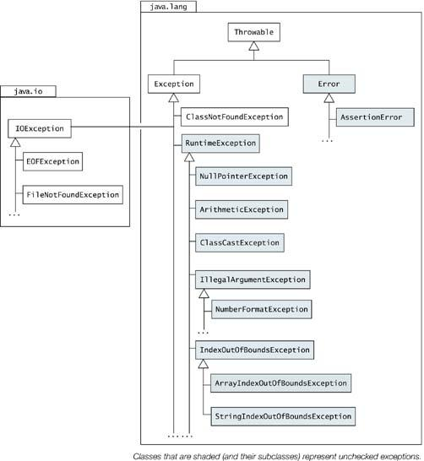

Which of the following is correct?
Is catch optional in try {} catch{} blocks? Nope it should atleast followed by finally.
Is catch optional in try {} catch {} – finally blocks? Yup.

Why Throwable is a class instead of interface?

http://java.sun.com/features/2002/03/gosling.html
http://c2.com/cgi/wiki?JavaExceptionQuestion
The reason that the Throwable and the rest of those guys are not interfaces is because we decided, or I decided fairly early on. I decided that I wanted to have some state associated with every exception that gets thrown. And you can't do that with interfaces; you can only do that with classes. The state that's there is basically standard. There's a message, there's a snapshot, stuff like that — that's always there. and also, if you make Throwable an interface the temptation is to assign, to make any old object be a Throwable thing. It feels stylistically that throwing general objects is probably a bad idea, that the things you want to throw really ought to be things that are intended to be exceptions that really capture the nature of the exception and what went on. They're not just general data structures.

Difference between Exceptions and Error?

Recoverable vs Un-Recoverable
An Error is a subclass of Throwable that indicates serious problems that a reasonable application should not try to catch. Most such errors are abnormal conditions. The ThreadDeath error, though a "normal" condition, is also a subclass of Error because most applications should not try to catch it.
A method is not required to declare in its throws clause any subclasses of Error that might be thrown during the execution of the method but not caught, since these errors are abnormal conditions that should never occur – Un Recoverable exceptions.

Facts about finally{}
What happens when you call System.exit(0); before finally block.
Finally block will never be executed.
A call to System.exit(0) halts the VM by calling
- All shutdown hooks
- Running all finalizers

Difference between Checked and Unchecked Exceptions?
http://www.artima.com/intv/handcuffs.html
http://www.mindview.net/Etc/Discussions/CheckedExceptions
http://www.artima.com/intv/solid2.html

Threads

Nulling a Thread?
Thread lThread = new Thread();
lThread.start();
lThread = null;

Ways to create threads in java.

When to use notify() and notifyAll()?
As a programmer, one must not rely on any particular selection algorithm or treatment of priorities; at least if you are trying to write a Java program that is platform independent. For example, because you don't know what order threads in the wait set will be chosen for resurrection by the notify command, you should use notify() (as opposed to notifyAll()) only when you are absolutely certain there will only be one thread suspended in the wait set. If there is a chance more than one thread will be suspended in the wait set at any one time, you should probably use notifyAll(). Otherwise, on some Java virtual machine implementations a particular thread may be stuck in the wait set for a very long time. If a notify() method always selects the most recent arrival from the wait set and the wait set always contains multiple threads, some threads that have been waiting the longest may never be resurrected.
http://www.artima.com/insidejvm/ed2/threadsynch.html

Explain wait and notify Monitors

Thread States

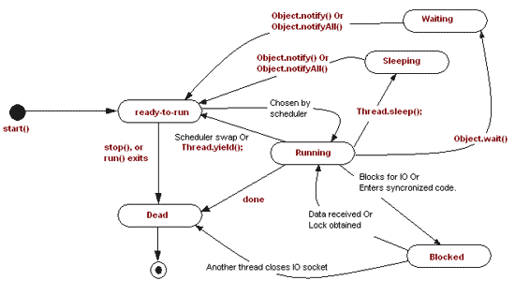

Thread methods?
http://java.sun.com/j2se/1.5.0/docs/guide/misc/threadPrimitiveDeprecation.html

new Thread.start() | Causes this thread to being execution. JVM calls the run after this.
new Thread.run()
Thread.sleep() | Causes current thread to cease execution temporarily.  TAKES MONITORS IF ANY WITH IT.
Thread.yield() | Causes current thread to pause temporarily and allow other threads to execute.
new Thread.join() | Waits for this thread to die
new Thread.destroy() | Destroys the thread without any cleanup. Any monitor remains locked. Not implemented.

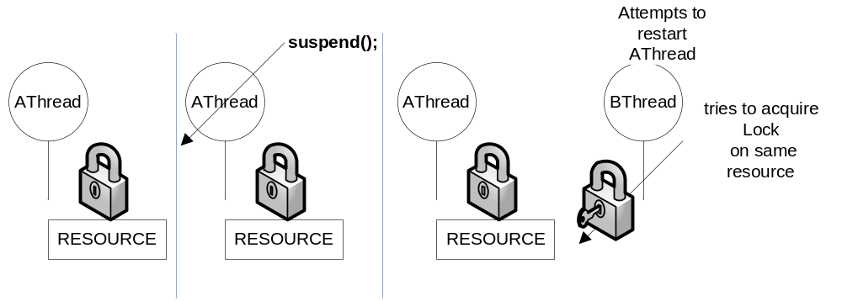

Explain new Thread.join()?
Imagine the following scenario. You are preparing for tomorrow's final examine and feel a little hungry. So, you give your younger brother ten bucks and ask him to buy a pizza for you. In this case, you are the main thread and your brother is a child thread. Once your order is given, both you and your brother are doing their job concurrently (i.e., studying and buying a pizza). Now, we have two cases to consider. First, your brother brings your pizza back and terminates while you are studying. In this case, you can stop studying and enjoy the pizza. Second, you finish your study early and sleep (i.e., your assigned job for today - study for tomorrow's final exam - is done) before the pizza is available. Of course, you cannot sleep; otherwise, you won't have a chance to eat the pizza. What you are going to do is to wait until your brother brings the pizza back. This is exactly the problem and solution we mentioned at the end of the previous section.

Thread join is designed to solve this problem. A thread can execute a thread join to wait until the other thread terminates. In our case, you - the main thread - should execute a thread join waiting for your brother - a child thread - to terminate. In general, thread join is for a parent to join with one of its child threads. Thread join has the following activities, assuming that a parent thread P wants to join with one of its child threads C.

* When P executes a thread join in order to join with C, which is still running, P is suspended until C terminates. Once C terminates, P resumes.
* When P executes a thread join and C has already terminated, P continues as if no such thread join has ever executed (i.e., join has no effect).

A parent thread may join with many child threads created by the parent. Or, a parent only join with some of its child threads, and ignore other child threads. In this case, those child threads that are ignored by the parent will be terminated when the parent terminates.

Why there is no (deprecated) Thread.stop()?
http://download.oracle.com/javase/1.4.2/docs/guide/misc/threadPrimitiveDeprecation.html

How to create Thread Dumps?
Ctrl + Break

Locks in JDK?
Synchronization is good, but not perfect. It has some functional limitations:
- Interrupting a thread that is waiting to acquire a Lock: Not possible.
- Polling for Locks and Attempting to acquire a Lock: Not possible.
- Synchronization also requires that locks be released in the same stack frame in which they were acquired, which most of the time is the right thing (and interacts nicely with exception handling), but a small number of cases exists where non-block-structured locking can be a big win.
http://www.ibm.com/developerworks/library/j-jtp10264/

JAVADOC: Note that Lock instances are just normal objects and can themselves be used as the target in a synchronized statement. Acquiring the monitor lock of a Lock instance has no specific locks that have deadlocked.
- In Java 1.5, the ThreadMXBean had only the findMonitorDeadlockedThreads() method, which found deadlocks caused by the synchronized keyword. We now also have the findDeadlockedThreads() method that is enabled when the Java virtual machine supports monitoring of ownable synchronizer usage. (i.e. the new locks or related constructs)

http://www.onjava.com/pub/a/onjava/2004/10/20/threads2.html

Mechanisms to avoid Deadlocks
http://www.onjava.com/pub/a/onjava/2004/10/20/threads2.html
Solution a: Never call a synchronized method of another class from a synchronized method.
- It's impractical: many useful Java methods are synchronized, and you'll want to call them from your synchronized method. As an example, many of the collection classes discussed in Chapter 8 have synchronized methods. To avoid the usage of collection classes from synchronized methods would prevent data from being moved or results from being saved.
- It's overkill: if the synchronized method you're going to call does not in turn call another synchronized method, there's no way that deadlock can occur. Furthermore, if the class or library is accessed only through its class interface—with no cross-calling—placing extra restrictions on using the library is silly.
Solution b: Lock some higher-order object that is related to the many lower-order objects we need to use.
Solution 1: Release locks reversed on the Acquired fashion
public void avoidDeadlock(){
try {
mLockA.lock();
mLockB.lock();
//Do Whatever you want
} finally {
mLockB.unlock(); // Line 7
mLockA.unlock();
}
}

At line 7 No Thread will be holding mLockA as it is not unlocked yet.
Solution 2: Use only locking objects—things that implement the Lock interface—and avoid use of the synchronized keyword. This allows the separation of the locks from the objects in the application
Solution 3: Understand which locks are assigned to which subsystems and understand the relationships between the subsystems. We define a subsystem as a class, group of classes, or library that performs a relatively independent service. The subsystem must have a documented interface that we can test or debug in our search for deadlocks. This allows us to form groups of locks and map out potential deadlocks.
Solution 4: Form a locking hierarchy within each subsystem. Unlike the other two steps, this can actually hurt the efficiency of the application. The subsystem needs to be studied. The relationship of the locks must be understood in order to be able to form a hierarchy that will have minimal impact on the efficiency of the application.

volatile VS synchronized ?
Where volatile only synchronizes the value of one variable between thread memory and "main" memory, synchronized synchronizes the value of all variables between thread memory and "main" memory, and locks and releases a monitor to boot. Clearly synchronized is likely to have more overhead than volatile.

Atomicity, Visibility and Ordering during Synchronization
http://jeremymanson.blogspot.com/2007/08/atomicity-visibility-and-ordering.html

ATOMICITY | VISIBILITY | ORDERING
class BrokenBankAccount {  private int balance;  synchronized int getBalance() {  return balance;  }  synchronized void setBalance(int x)  throws IllegalStateException {  balance = x;  if (balance < 0) {  throw new IllegalStateException("Negative Balance");  }  }  void deposit(int x) {  int b = getBalance();  setBalance(b + x);  }  void withdraw(int x) {  int b = getBalance();  setBalance(b - x);  }  } | class LoopMayNeverEnd {  boolean done = false;  void work() {  while (!done) {  // do work  }  }  void stopWork() {  done = true;  }  } | class BadlyOrdered {  boolean a = false;  boolean b = false;  void threadOne() {  a = true;  b = true;  }  boolean threadTwo() {  boolean r1 = b; // sees true  boolean r2 = a; // sees false  boolean r3 = a; // sees true  return (r1 && !r2) && r3;  // returns true  }  }

Synchronization

Can constructors be synchronized?

In Java, synchronization of contructors is not allowed (results in a compile time error) as only the thread which is constructing the object should have access to the object and hence any other thread is not granted access until the construction of the object is complete. So, no explicit synchronization needed for constructors.
Caution: Even though other threads will be given the access to an object only when it's already constructed, but if the constructor itself is allowing a memory leak then an incomplete object can also be accessed by other threads which is obviously undesirable as the behavior is undefined. This may happen in case we are maintaining a Collection of instances (say with the reference 'instances') of the class and if the constructor is using the statement 'instances.add(this);' to add the current instance to the Collection then a half-baked object may be accessed by other threads.

Synchronization of static fields in a synchronized instance method
A thread needs to acquire the monitor of the Class object of the class in case synchronized static method, but how can you handle the synchronization of static fields in instance methods?
In Java, an instance method can access static fields as well (vice versa is not possible for the obvious reason), suppose a synchronized instance method having code accessing static fields, is being accessed on different objects by different threads (which is quite possible as each of the different threads would have acquired monitor of one of the different objects) then in such a case we can't guarantee a exclusive access to those static fields. The reason is very simple - a static field doesn't belong to an instance instead to the class and hence the access to it is not controlled by monitors associated with the instances of the class instead the access to them is controlled by the monitor of the Class object associated with the class. Hence, we need to be very careful in such scenarios and any synchronized instance method should have an explicit synchronized block for accessing static fields if the static fields require an exclusive access. This synchronized block can specify the Class object associated with the class and hence a thread which enters the synchronized instance method after acquiring the monitor of the particular instance will first need to acquire the monitor of the Class object as well before executing the code which accesses static fields. And this way we can guarantee exclusive access to the static fields accessed inside a synchronized instance method.

Synchronizing static vs instance methods in java
Class Level Monitor:
Instance Level Monitor:
Okay, what happens when a thread tries to acquire an object instance lock when the class level lock is already being used by another thread?
It CAN access any instance method, which is synchronized.

Inner Classes

What are the different flavors of Inner Classes?
Entity | Declaration Context | Accessibility Modifiers | Enclosing Instance | Direct Access to Enclosing Context | Declarations in Entity Body
Top-Level Class (or Interface) | Package | public or default | No | N/A | All that valid in a class or interface body
Static Member  Class or Interface | As static member of enclosing class or interface | public  private  protected  default | No | Static members declared in the enclosing context | All that are valid in a class or interface body
Non-Static Member  Class or Interface | As non-static member of enclosing class or interface | public  private  protected  default | Yes | All members in the enclosing context | Can Access only non-static declarations and final static fields
Local Class | In block with static context | None | No | Static members in enclosing context + final local variables | Only non-static declarations + final static fields
Local Class | In block with non-static context | None | Yes | All members in enclosing context + final local variables | Only non-static declarations + final static fields
Anonymous Class | As expression in static context | None | No | Static members in enclosing context + final local variables | Only non-static declarations + final static fields
Anonymous Class | As expression in static context | None | Yes | All members in enclosing context + final local variables | Only non-static declarations + final static fields

interface IDrawable { // (1)
void draw();
}
class Shape implements IDrawable { // (2)
public void draw() { System.out.println("Drawing a Shape."); }
}

class Painter { // (3) Top-level Class

public Shape createShape() { // (4) Non-static Method
return new Shape(){ // (5) Extends superclass at (2)
public void draw() {
System.out.println("Drawing a new Shape.");
}
};
}
public static IDrawable createIDrawable() { // (7) Static Method
return new IDrawable() { (8) Implements interface at (1)
public void draw() {
System.out.println("Drawing a new IDrawable.");
}
};
}
}

Usage of final in Inner classes?

Usage of Anonymous Classes and Inner classes
http://www.javaworld.com/javaworld/javaqa/2000-03/02-qa-innerclass.html
- An Inner class gives more OO. Separates concerns Eg: Tree object from its TreeSearch Algorithms
- Inner classes provide more structural Hierarchy than what a java Package provides.
- Convenient way to provide callbacks.
- Improves Performance in cases Eg: A big switch or If-else based approach for a Java Swing Action Listener with n comparisons would involve n/2 comparisons in the average case. Inner classes allow us to set up a 1:1 correspondence between the action performer and the action listener.

NIO

Explain benefits of NIO

Block IO
Streams read data one byte a time.
Streams are unidirectional.

Channels are bi-directional reflecting the real-time OS like Linux. Data is read in blocks using Buffer objects.
From the InputStream or OutputStream get the channel and pass your Buffer Object .
The channel then either reads or writes into the Buffer objects

File Locking
File Locking is allowed. [Advisory locks , Shared and Exclusive locks are allowed]

Asynchronous I/O
All IO operations are Synchronous and Blocking.
The central object in asynchronous I/O is called the Selector. A Selector is where you register your interest in various I/O events, and it is the object that tells you when those events occur.

Charset support

java.util.concurrent

Explain features of the new concurrent package in JDK 1.5?
- Lock Objects
- Executors – Separates Thread creation and Thread management.
- ThreadPool
- Concurrent Collections
- Atomic Variables
http://java.sun.com/docs/books/tutorial/essential/concurrency/highlevel.html

JVM

Explain JVM?
http://www.artima.com/insidejvm/ed2/jvm2.html
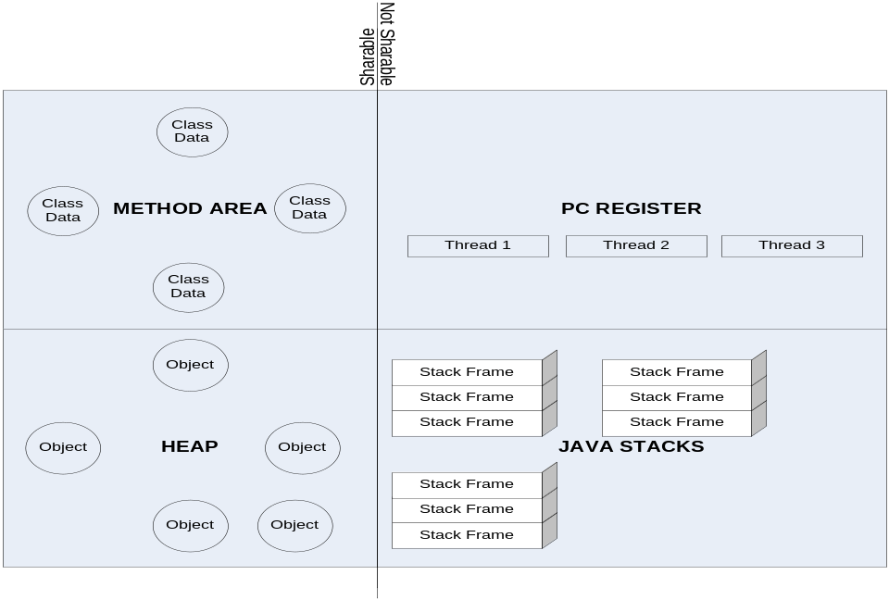

Garbage Collection

What is the use of WeakReferences introduction in Java? Explain Reach ability of Objects in Java?
http://weblogs.java.net/blog/enicholas/archive/2006/05/understanding_w.html
http://www.pawlan.com/Monica/refobjs/
http://java.sun.com/developer/technicalArticles/ALT/RefObj/index.html
http://mindprod.com/jgloss/weak.html
http://www.kdgregory.com/index.php?page=java.refobj

Soft – An object not strongly reachable and not reachable by weak/Phantom but at least one path to the object with a Soft reference

Weak - Not strongly/Softly reachable and reachable but at least one path to the object with a weak reference

The only real difference between a soft reference and a weak reference is that the garbage collector uses algorithms to decide whether or not to reclaim a softly reachable object, but always reclaims a weakly reachable object. So SoftReferences are good candidates for Caching solution.

Phantom - An object is phantomly reachable when the garbage collector finds no strong, soft, or weak references, but at least one path to the object with a phantom reference. Phantomly reachable objects are objects that have been finalized, but not reclaimed.

Reference Queue – If the Referent Object is not available the Reference Object will be automatically inserted to the Reference Queue and available for GC.

Difference between Weak and Phantom Reference – Difference is when Enqueuing happens. WeakReferences are enqueued as soon as the object [Referent] becomes weakly reachable. This happens before finalization or Garbage Collection. Therefore there is possibility by an unorthodox call to finalize() it could be resurrected. But PhantomReferences are placed into the ReferenceQueue only when the object is physically removed from the HEAP.

Why Phantom References
  - They allow user to determine when an Object was removed from Memory. They are in fact the only way to determine that. This isn't generally that useful, but might come in handy in certain very specific circumstances like manipulating large images: if you know for sure that an image should be garbage collected, you can wait until it actually is before attempting to load the next image, and therefore make the dreaded OutOfMemoryError less likely.
  - Assume the Referent is marked for Garbage. When finalize() is called on the Referent it can try to resurrect. So GC has to run again before the Object can be finally removed. As GC is Arbitrary this can occur after several GC Cycles. This can lead to OutofMemoryError. This can never happen in PhantomReference as once it is enqueued there is no way to get a pointer to now-dead object.
 | Soft | Weak | Phantom
Definition | An object not strongly reachable A soft reference is exactly like a weak reference, except that it is less eager to throw away the object to which it refers. An object which is only weakly reachable (the strongest references to it are WeakReferences) will be discarded at the next garbage collection cycle, but an object which is softly reachable will generally stick around for a while. | An object which is only weakly reachable (the strongest references to it are WeakReferences) will be discarded at the next garbage collection cycle.  A weak reference is, as its name suggests, a reference that doesn't even try to put up a fight to prevent its referent from being collected. If there are no strong or soft references to the referent, it's pretty much guaranteed to be collected. | Phantomly reachable objects are objects that have been finalized, but not reclaimed. Phantom references differ from soft and weak references in that they're not used to access their referents. Instead, their sole purpose is to tell you when their referent has already been collected. While this seems rather pointless, it actually allows you to perform resource cleanup with more flexibility than you get from finalizers.  Phantomly reachable objects are objects that have been finalized, but not reclaimed. The garbage collector will never clear a phantom reference. All phantom references must be explicitly cleared by the program.
ReferenceQueue | N/A |  | The only use for such a reference is keeping track of when it gets enqueued into a ReferenceQueue, as at that point you know the object to which it pointed is dead.
get() |  | Returns weakly referenced object | It always returns null, even if the referent is still strongly referenced.
Use | SoftReferences aren't required to behave any differently than WeakReferences, but in practice softly reachable objects are generally retained as long as memory is in plentiful supply. This makes them an excellent foundation for a cache, such as the image cache described above, since you can let the garbage collector worry about both how reachable the objects are (a strongly reachable object will never be removed from the cache) and how badly it needs the memory they are consuming.  To keep objects alive even after clients have removed their references (memory-sensitive caches), in case clients start asking for them again by key. | Containers that automatically delete objects no longer in use. | first, they allow you to determine exactly when an object was removed from memory. They are in fact the only way to determine that. This isn't generally that useful, but might come in handy in certain very specific circumstances like manipulating large images: if you know for sure that an image should be garbage collected, you can wait until it actually is before attempting to load the next image, and therefore make the dreaded OutOfMemoryError less likely.
GC | The garbage collector might or might not reclaim a softly reachable object depending on how recently the object was created or accessed, but is required to clear all soft references before throwing an OutOfMemoryError. | Weakly reachable objects are finalized some time after their weak references have been cleared. The only real difference between a soft reference and a weak reference is that the garbage collector uses algorithms to decide whether or not to reclaim a softly reachable object, but always reclaims a weakly reachable object. | The garbage collector will never clear a phantom reference. All phantom references must be explicitly cleared by the program.
 |  |  | Several pages back, I noted that finalizers are not guaranteed to be called. Neither are phantom references. If the collector doesn't run, it will never collect unreachable objects, and any phantom references won't be enqueued.

Explain various ways to call GC
System.gc();
Runtime.getRuntime().gc()

Common Java

A null variable may be used to access a class variable.
public class MyClass {
static String str="what the hell";
public MyClass method(){
//System.out.println(str);
return null;
}
public static void main( String[] args ) {
System.out.println(new MyClass().method().str);
//System.out.println(MyClass.str);
}
}
Prints: what the hell

How to construct Immutable Objects?
http://www.ibm.com/developerworks/java/library/j-jtp02183.html
An object is considered immutable if its state cannot change after it is constructed. Maximum reliance on immutable objects is widely accepted as a sound strategy for creating simple, reliable code.
Immutable objects are particularly useful in concurrent applications. Since they cannot change state, they cannot be corrupted by thread interference or observed in an inconsistent state.
- Don't provide "setter" methods — methods that modify fields or objects referred to by fields.
- Make all fields final and private.
- Don't allow subclasses to override methods. The simplest way to do this is to declare the class as final. A more sophisticated approach is to make the constructor private and construct instances in factory methods.
- If the instance fields include references to mutable objects, don't allow those objects to be changed:
  - Don't provide methods that modify the mutable objects.
  - Don't share references to the mutable objects. Never store references to external, mutable objects passed to the constructor; if necessary, create copies, and store references to the copies. Similarly, create copies of your internal mutable objects when necessary to avoid returning the originals in your methods.
Benefits
- Freedom to cache
- Inherent Thread Safety
- Good Keys
- Safe in presence of ill-behaved code. Nothing can change the state of that Object.
- Reduces need to take care of Thread Safe

Explain Serializable and Externalizable?
http://java.sun.com/developer/technicalArticles/Programming/serialization/

- Use transient to tell JVM not to serialize any of the members in a serializable classs.
try {
PersistentTime time = null;
FileInputStream fis = null;
ObjectInputStream in = null;
fis = new FileInputStream(filename);
in = new ObjectInputStream(fis);
time = (PersistentTime)in.readObject();
in.close();
} catch(IOException ex) {
}
- By using a built-in feature of the serialization mechanism, developers can enhance the normal process by providing two methods inside their class files. Those methods are
private void writeObject( ObjectOutputStream out )
throws IOException;
and call out.defaultWriteObject();
private void readObject( ObjectInputStream in )
throws IOException, ClassNotFoundException;

and call
in.defaultReadObject();

private void writeObject(ObjectOutputStream out) throws IOException
{
out.defaultWriteObject();
}
private void readObject(ObjectInputStream in) throws IOException, ClassNotFoundException
{
// our "pseudo-constructor"
in.defaultReadObject();
// now we are a "live" object again, so let's run rebuild and start
startAnimation();

}
- If you wish not to implement Serialization, implement these two methods in your subclass [which extends a class that implements Serializable interface] and tell JVM not to serialize your object by throwing this exception NotSerializableException;

Externalizable | public void writeExternal(ObjectOutput out)  throws IOException;
Externalizable | public void readExternal(ObjectInput in)  throws IOException, ClassNotFoundException;
Externalizable | serialVersionUID

What is the use of Cloneable?
Tag interface where the implementor overrides Object.clone().

Calendar vs Date?
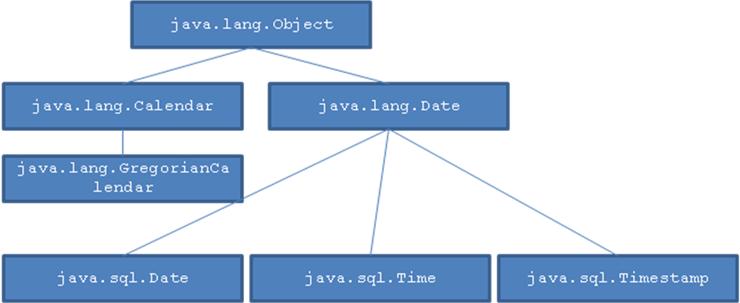
java.util.Date
Think of java.util.Date as an abstract instant in time. It has no time zone, calendar, clock or any other structuring we've put on time. A Date only knows how many milliseconds had elapsed since Jan 1, 1970 00:00 UTC when this instant occurred
Date testDate = calendarObject.getTime();
The bottom line: If you just need to keep track of a date/ time as most people do, just use a java.util.Date

Using java.util.Date has one more advantage if one wants to move objects around over RMI. java.util.Calendar and java.util.GregorianCalendar do not implement Serializable. One could sub-class GregorianCalendar and make it Serializable.

java.util.Calendar
While you can now format and create dates,
- but how do we set and get specific parts of a date such as the hour, the day, or the minute?
- And how do we add and subtract values to these parts of a date?
If you need to also remember a specific time zone with it, choose Calendar. If you need to specifically use western calendar system, use GregorianCalendar.

What is the use of Comparable?
- This interface imposes a total ordering on the objects of each class that implements it. This ordering is referred to as the class's natural ordering, and the class's compareTo method is referred to as its natural comparison method.
- Every Tree based collections should implement this.

JDK 1.5

Metadata Annotations

Autoboxing and Auto-Unboxing of Primitive Types

Enhanced For Loop
- Traverse through Collection instead of Iterating over.
- Traverse over an Array

Enumerated Types

Problems with int enum pattern
- Not typesafe : a Season is just an int
- No namespace : should prefix it with SEASON_
- Brittle : They are just compile-time constants
- Printed values are uninformative

New enum class
- Supports Swtich
- java.util.EnumSet
- java.util.EnumMap

Static Import
The static import feature, implemented as "import static", enables you to refer to static constants from a class without needing to inherit from it. Instead of BorderLayout.CENTER each time we add a component, we can simply refer to CENTER.

import static java.awt.BorderLayout.*;
getContentPane().add(new JPanel(), CENTER);

Formatted Output
System.out.printf("name count%n");
System.out.printf("%s %5d%n", user,total);

Formatted Input
Scanner s= new Scanner(System.in);
String param= s.next();
int value=s.nextInt();
s.close();

Varargs
void argtest(Object ... args) {
for (int i=0;i <args.length; i++) {
}
}
argtest("test", "data");

Generics
http://java.sun.com/j2se/1.5/pdf/generics-tutorial.pdf
https://www6.software.ibm.com/developerworks/education/j-generics/j-generics-a4.pdf

Generics give the Java’s split type system more type safety. It provides parameterized types for Java enabling.

Erasure Principle
It has been adopted based on java compiler instead of extending JVMs instruction set by using “erasure” principle – compiler uses generic parameterized type information to ensure type safety and then erase it before generating the bytecode.

Co-Variance - Issue with Arrays:
Generics are NOT co-variant, means if Integer extends Number then Integer[] is also a Number[].
List<Integer> intList = new ArrayList<Integer>();
List<Number> numberList = intList; // invalid
numberList.add(new Float(3.1415)); // breaks type safety guarantee

Also we cannot instantiate an array of Generic type collections.
List<String>[] listArray = new List<String>[10]; // illegal

Note: Though this it legally allowed and will not give compile time exception it will return runtime exception.
Number[] lNumberArray = new Integer[1];
Integer[] lIntegerArray = new Integer[1];
lNumberArray[0] = new Float( "230.0" );

Also we cannot instantiate an array of Generic type collections.
Why it is not Co-Variant
An object array Object[] mObjectArray can reference an array of List<String>().
If the same object array can be allowed to reference an array of List<Integer> problem!!

Arrays
Permitting Array like construction could create problems, because arrays in Java language are covariant, but parameterized types are not. Because any array type is type-compatible with Object[] (a Foo[] is an Object[]), the following code would compile without warning, but it would fail at runtime, which would undermine the goal of having any program that compiles without unchecked warnings be type-safe:

List<String>[] listArray = new List<String>[10]; // illegal
Object[] objArray = listArray;
objArray[0] = new List<Integer>();
String s = listArray[0].get(0); //ClassCastException

If, on the other hand, listArray were of type List<?>, an explicit cast would be required in the last line. Although it would still generate a runtime error, it would not undermine the type-safety guarantees offered by generics (because the error would be in the explicit cast). So arrays of List<?> are permitted.

Types versus classes
The addition of generic types has made the type system in the Java language more complicated. Previously, the language had two kinds of types -- reference types and primitive types. For reference types, the concepts of type and class were basically interchangeable, as were the terms subtype and subclass. With the addition of generics, the relationship between type and class has become more complex.

Weird 1: List<Integer> and List<Object> are distinct types, but they are of the same class.
Even though Integer extends Object, a List<Integer> is not a List<Object>, and it cannot be assigned or even cast to List<Object>.

Weird 2: On the other hand, now there is a new weird type called List<?>, which is a supertype of both List<Integer> and List<Object>. And there is the even weirder List<? extends Number>. The structure and shape of the type hierarchy got a lot more complicated. Types and classes are no longer mostly the same thing.

New meanings for extends
Before the introduction of generics in the Java language, the extends keyword always meant that a new class or interface was being created that inherited from another class or interface.

With the introduction of generics, the extends keyword has another meaning. You use extends in the definition of a type parameter (Collection<T extends Number>) or a wildcard type parameter (Collection<? extends Number>). When you use extends to denote a type parameter bound, you are not requiring a subclass-superclass relationship, but merely a subtype-supertype relationship.

It is also important to remember that the bounded type does not need to be a strict subtype of the bound; it could be the bound as well. In other words, for a Collection<? extends Number>, you could assign a Collection<Number> (although Number is not a strict subtype of Number) as well as a Collection<Integer>, Collection<Long>, Collection<Float>, and so on.
In any of these meanings, the type on the right-hand side of extends can be a parameterized type (Set<V> extends Collection<V>).

Implications of Erasure Principle:
- One single class cannot implement both Comparable<String> and Comparable<Integer> interface as they both have to implement compareTo() method.
public class DecimalString implements Comparable<Number>, Comparable<String> { ... } // nope
- Another implication is using cast and instanceof operator with generic type parameters. It doesn’t make any sense to use them, as with erasure the generic type parameters will be replaced by Object.

public <T> T naiveCast(T t, Object o) { return (T) o; }

A Generic class is shared by all its invocations.

List<String> lStringList;
List<Integer> lIntegerList;
System.out.println( lStringList.getClass() == lIntegerList.getClass() )

will return true.

So it’s illegal to refer to the type parameters of a type declaration in a static method or initializer or in the declaration or initializer of a static variable.

Wildcards – Reading and Writing with Wildcards:
Collection<?> pronounced as Collection of unknown
Bounded Wildcards:
- ? extends T [wild cards with an upper bound] an unknown type that extends T.
- ? super T [wild cards with a lower bound] an unknown type super of T.

Concurrent Package

Queues in Concurrent Package?

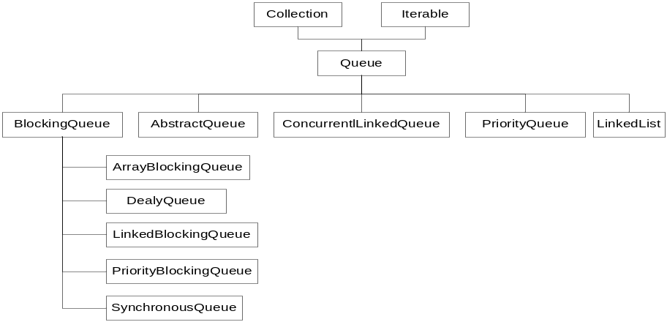
offer() | returns false when the Queue is full
put() | Producer blocks when there is no space in the Queue
take() | Consumer blocks when there is nothing in the Queue

Java EE

JMS

Difference between "Topic" and "Queue"?
Queue | Topic
Point to Point –intended for one recipent | Publish Subsribe
One Producer and One consumer per Message | Producers publish to ACTIVE Consumers
Store and Forward | Broadcast
There can be more than one Producer and one consumer | The topic messages can be stored and made available for inactive consumers

What is DurableSubsriber?
Nondurable subscriptions last for the lifetime of their subscriber object. This means that a client will only see the messages published on a topic while its subscriber is active. If the subscriber is not active, it is missing messages published on its topic. At the cost of higher overhead, a subscriber can be made durable.

A durable subscriber registers a durable subscription with a unique identity that is retained by JMS. Subsequent subscriber objects with the same identity resume the subscription in the state it was left in by the prior subscriber. If there is no active subscriber for a durable subscription, JMS retains the subscription’s messages until they are received by the subscription or until they expire. All JMS providers must be able to run JMS applications that dynamically create and delete durable subscriptions. Some JMS providers may, in addition, provide facilities to administratively configure durable subscriptions. If a durable subscription has been administratively configured, it is valid for it to silently override the subscription specified by the client. An inactive durable subscription is one that exists but does not currently have a message consumer subscribed to it.

What is the use of setClientId()?
The purpose of client identifier is to associate a connection and its objects with a state maintained on behalf of the client by a provider. The only such state identified by JMS is that required to support durable subscriptions.

Use of Sessions
- It is a factory for its message producers and consumers.
- It supplies provider-optimized message factories.
- It supports a single series of transactions that combine work spanning its producers and consumers into atomic units.
- It defines a serial order for the messages it consumes and the messages it produces.
- It retains messages it consumes until they have been acknowledged.
- It serializes execution of message listeners registered with its message consumers.

Is there durability in Queue?
A "durable message" is a message where the JMS server will hold on to a message if the subscriber is temporarily unavailable. So the durability is defined by the relationship between a "Topic Subscriber" and the "JMS Server". Durability is applicable only to publish/Subscribe paradigm. For this to happen subscribers need to register themselves with a unique "client id ".
A "persistent message" is a message that defines the relationship between a "Message Producer" and the "JMS Server". This can be established for both
point-to-point and publish/subscribe. This has to do with the guaranteed once only delivery of the message by persisting the message after it has been received from the message producer.

Describe ACK modes in JMS?
If a session is not transacted, there are three acknowledgment options, and recovery is handled manually:
DUPS_OK_ACKNOWLEDGE | This option instructs the session to lazily acknowledge the delivery of messages. This is likely to result in the delivery of some duplicate messages if JMS fails, so only consumers that are tolerant of duplicate messages should use it.  Benefits: Reduction of session overhead achieved by minimizing the work the session does to prevent duplicates.
AUTO_ACKNOWLEDGE | With this option, the session automatically acknowledges a client’s receipt of a message when it has either successfully returned from a call to receive or the MessageListener it has called to process the message successfully returns.
CLIENT_ACKNOWLEDGE | With this option, a client acknowledges a message by calling the message’s acknowledge method. Acknowledging a consumed message automatically acknowledges the receipt of all messages that have been delivered by its session [ie. Any other Consumers].

When CLIENT_ACKNOWLEDGE mode is used, a client may build up a large number of unacknowledged messages while attempting to process them. A JMS provider should provide administrators with a way to limit client over-run so that clients are not driven to resource exhaustion and ensuing failure when some resource they are using is temporarily blocked.

A session’s recover method is used to stop a session and restart it with its first unacknowledged message. In effect, the session’s series of delivered messages is reset to the point after its last acknowledged message. The messages it now delivers may be different from those that were originally delivered due to message expiration and the arrival of higher-priority messages. A session must set the redelivered flag of messages it redelivers due to a recovery.

What are the delivery modes in JMS?

MESSAGE  DELIVERY  MODES | Description
NON_PERSISTENT | The lowest-overhead delivery mode because it does not require that the message be logged to stable storage. A JMS  Provider failure can cause a NON_PERSISTENT message to be lost.
PERSISTENT | This mode instructs the JMS provider to take extra care to insure the message is not lost in transit due to a JMS provider failure.

A JMS provider must deliver a NON_PERSISTENT message at-most-once. This means that it may lose the message, but it must not deliver it twice.
A JMS provider must deliver a PERSISTENT message once-and-only-once. This means a JMS provider failure must not cause it to be lost, and it must not deliver it twice.
Session maintains the Ordering only within the Delivery Mode. If a PERSISTENT and a NON_PERSISTENT are sent to the same destination ordering will be preserved PERSISTENT among and NON_PERSISTENT messages individually.

What is PreserveUndelivered?
Provider specific message property which is set by the application if this message should be placed into special system queue in case it could not be delivered. - JMS_TIBCO_PRESERVE_UNDELIVERED

What is the advantage of using a MOM and Asynchrony?
www.theserverside.com/tt/articles/content/JMSArchitecture/JMSApplicationArchitemmctures.pdf

Loose-Coupling
- Process Level – Producer process can be up and send messages to the destination and not worry about the consumer process of the message being up and running.
- Application Level – While RPC used in EJBs, CORBA, DCOM, RMI etc are interface centric. Any change can affect the consumers. Messaging dictates data centric development.

Describe how will you get a Session?
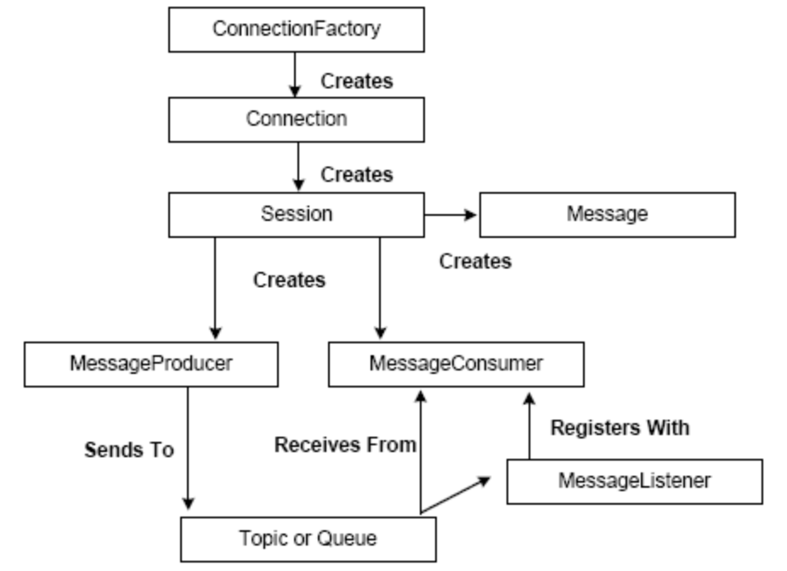

InitialDirContext lInitialDirContext = new InitialDirContext( lEnvMap );
//Send all the configuration to it
//String lContextFactory;
//String lUserName;
//String lPassword;

ConnectionFactory lConnectionFactory = ( ConnectionFactory )
lInitialDirContext.lookup( “ConnectionFactoryClassName” );
lConnection = lConnectionFactory.createConnection( lUserName, lPassword );
Session lSession = lConnection.createSession( lTransacted, lAckModeInt );
// Set Exception Listener
lConnection.setExceptionListener( MyExceptionListener );
// Set Message Listener
lSession.setMessageListener( new MessageListener() );

// Producer
MessageProducer lMessageProducer = lSession.createProducer( lDestination );
TextMessage lTextMessage = lSession.createTextMessage();
lTextMessage.clearBody();
lTextMessage.clearProperties();
// specific for TIBCO EMS
lTextMessage.setBooleanProperty( “PRESERVE_UNDELIVERED”,
true );
lTextMessage.setText( getMessageString( pMessage ) );
lProducer.send( lTextMessage, lDeliveryMode, lPriority, lTimeToLive );
lReturnMessageId = lTextMessage.getJMSMessageID();

// Consumer(can be QueueReceiver or TopicReceiver
MessageConsumer lMessageConsumer = lSession.createConsumer( lDestination );
lMessageConsumer.setMessageListener( new MessageListener() );
lConnection.start();
Message lMessage1 = lMessageConsumer.receive();
lMessage1.acknowledge();

//
Message lMessage2 = lMessageConsumer.receive();
Message lMessage3 = lMessageConsumer.receive();
lMessage3.acknowledge();

Setting MessageListener with Session vs Consumer

TODO-TODO-TODO-TODO-TODO

Message Types in JMS?

Message type | Description
Message | The base class. This message type is used for event notification and does not have a payload.
BytesMessage | The payload is stored as an array of bytes. This message type is useful for exchanging data in an application’s native format and when JMS is used as a transport between two systems, where the JMS client does not know the message payload type.
TextMessage | Data is stored as a string. This message type is useful for exchanging simple text messages and for more complex character data, such as XML documents.
StreamMessage | A Stream message is a sequence of primitive Java types. The message object keeps track of the order and the types of these primitives within the stream. Formal conversion rules apply; for example, an exception is thrown if a JMS application tries to read a double value as a short value. If the data structure is unknown, the generic method readObject() can be used to return the next object in the stream. If the structure of the data is known, the JMS client can be specific about the type of object being accessed.
MapMessage | The payload of a MapMessage is stored as a set of name-value pairs. The name is defined as a string and the value is typed. The MapMessage is useful for delivering keyed data that can change from one message to the next. Data can be accessed by using getMapNames(), which returns a Java Enumeration object. It is possible to iterate through the MapMessage by using hasMoreElements() to retrieve the mapped name-value pairs.
ObjectMessage | The Object message carries a serializable Java Object as its payload. It is useful for exchanging Java objects.

Design Patterns in JMS
  - Inversion of Control
  - Observer Pattern when I use Publish-Subscribe model
  - Factory Pattern is there

Servlet Technology

Web Application
- From a programmer's point of view, a Web application corresponds to one ServletContext object. All Servlets’ inside a Web application share the same ServletContext instance.
- All Web servers have at least one context, called the default context. It handles requests whose URI paths match no other context prefix. (So, for example, it would handle requests for /index.html or /images/tile.gif)
http://java.sun.com/developer/technicalArticles/Servlets/servletapi/

Difference between "Get" and "Post"?

GET | POST
Allows up to 2K | More than GET
GET can be cached and used in any system as Bookmarks
Idem-potent | POST is not idem-potent.

<HTML>
<BODY>
<FORM METHOD="post" ACTION="/cgi-bin/script.pl">
<INPUT TYPE="text" NAME="in" SIZE="20"
MAXLENGTH="40" VALUE="hello there">
<INPUT TYPE="submit" NAME="button" VALUE="Send">
</FORM>
</BODY>
</HTML>

Now, when the web browser sends the form data, the URL will be unchanged. Instead, the
HTTP request received by the web browser from the POST method will look like this:

POST /cgi-bin/script.pl HTTP/1.0
Content-type: application/x-www-form-urlencoded
Content-length: 26

in=hello+there&button=Send

In contrast, the HTTP request for the GET method is simpler:

GET /cgi-bin/script.pl?in=hello+there&button=Send HTTP/1.0

What is the default HTTP Method used in a HTML Form
GET

CGI vs Servlets
CGI starts a heavy-weight process per request.
In Servlets though the JVM is a heavy weight process, Servlets as such stay loaded and client requests for Servlet Resources are handled as separate threads of a single running servlet. So not that for every request a JVM is loaded.

Though many Web Servers now able to keep a single Perl program running, Servlet is a J2EE application. Servlets can provide security and all other stuffs.

Various HTTP Methods – Optional Read for better understanding
http://www.w3.org/Protocols/rfc2616/rfc2616-sec9.html

Methods can also have the property of "idempotence" in that (aside from error or expiration issues) the side-effects of N > 0 identical requests is the same as for a single request.
Method | Description | Idempotent
OPTIONS | The OPTIONS method represents a request for information about the communication options available on the request/response chain identified by the Request-URI. This method allows the client to determine the options and/or requirements associated with a resource, or the capabilities of a server, without implying a resource action or initiating a resource retrieval. | Yes
GET | Retrieve whatever information (in the form of an entity) is identified by the Request-URI. | YES
HEAD | The HEAD method is identical to GET except that the server MUST NOT return a message-body in the response. The metainformation contained in the HTTP headers in response to a HEAD request SHOULD be identical to the information sent in response to a GET request. This method can be used for obtaining metainformation about the entity implied by the request without transferring the entity-body itself. This method is often used for testing hypertext links for validity, accessibility and recent modification. | YES
POST | The POST method is used to request that the origin server accept the entity enclosed in the request as a new subordinate of the resource identified by the Request-URI in the Request-Line. POST is designed to allow a uniform method to cover the following functions:  - Annotation of existing resources;  - Posting a message to a bulletin board, newsgroup, mailing  list, or similar group of articles;  - Providing a block of data, such as the result of submitting a  form, to a data-handling process;  - Extending a database through an append operation.
PUT | The PUT method requests that the enclosed entity be stored under the supplied Request-URI.  - If the Request-URI refers to an already existing resource, the enclosed entity SHOULD be considered as a modified version of the one residing on the origin server.  - If the Request-URI does not point to an existing resource, and that URI is capable of being defined as a new resource by the requesting user agent, the origin server can create the resource with that URI.  - If a new resource is created, the origin server MUST inform the user agent via the 201 (Created) response.  - If an existing resource is modified, either the 200 (OK) or 204 (No Content) response codes SHOULD be sent to indicate successful completion of the request.  - If the resource could not be created or modified with the Request-URI, an appropriate error response SHOULD be given that reflects the nature of the problem. The recipient of the entity MUST NOT ignore any Content-* (e.g. Content-Range) headers that it does not understand or implement and MUST return a 501 (Not Implemented) response in such cases.  The fundamental difference between the POST and PUT requests is reflected in the different meaning of the Request-URI. The URI in a POST request identifies the resource that will handle the enclosed entity. That resource might be a data-accepting process, a gateway to some other protocol, or a separate entity that accepts annotations. In contrast, the URI in a PUT request identifies the entity enclosed with the request -- the user agent knows what URI is intended and the server MUST NOT attempt to apply the request to some other resource. If the server desires that the request be applied to a different URI, it MUST send a 301 (Moved Permanently) response; the user agent MAY then make its own decision regarding whether or not to redirect the request. | YES
DELETE | The DELETE method requests that the origin server delete the resource identified by the Request-URI. This method MAY be overridden by human intervention (or other means) on the origin server. The client cannot be guaranteed that the operation has been carried out, even if the status code returned from the origin server indicates that the action has been completed successfully. However, the server SHOULD NOT indicate success unless, at the time the response is given, it intends to delete the resource or move it to an inaccessible location. | YES
TRACE | The TRACE method is used to invoke a remote, application-layer loop- back of the request message. The final recipient of the request SHOULD reflect the message received back to the client as the entity-body of a 200 (OK) response. The final recipient is either the origin server or the first proxy or gateway to receive a Max-Forwards value of zero (0) in the request. A TRACE request MUST NOT include an entity. | YES
CONNECT | This specification reserves the method name CONNECT for use with a proxy that can dynamically switch to being a tunnel

What is a Servlet?
A servlet is a Java technology-based Web component, managed by a container, that generates dynamic content. They are run by a Java technology-enabled Web server. Containers, sometimes called servlet engines, are Web server extensions that provide servlet functionality. Servlets interact with Web clients via a request/response paradigm implemented by the servlet container.

What is a servlet container?

The servlet container is part of a Web server or application server that provides the network services over which requests and responses are sent, decodes MIME-based requests, and formats MIME-based responses. A servlet container also contains and manages servlets through their lifecycle. A servlet container can be built into a host Web server, or installed as an add-on component to a Web Server via that server’s native extension API. Servlet containers can also be built into or possibly installed into Web-enabled application servers.
All servlet containers must support HTTP as a protocol for requests and responses, but additional request/response-based protocols such as HTTPS (HTTP over SSL) may be supported.

Lifecycle of a Servlet and what is the effect of an application calling destroy?
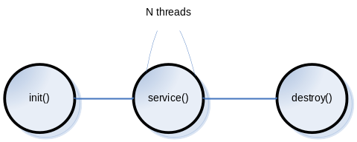
Typically, a servlet class is instantiated the first time it is invoked. This is called lazy instantiation. The same instance will be used over several client requests, so all members that are declared in that Servlet are shared across clients. That is what is meant by multi threaded model, multiple clients that access the same instance.
Web Container (Servlet Container)
- Instantiates each event listener
- For all Listener's that instantiated on step 1, and that implements ServletContextListener the container calls its contextInitialized() method.
- instantiate each instance of Filter configured in web-app, for that particular servlet.
- instantiate each instance of servlet with load-on-startup configured as 1
call Servlet.init() method.

What is Pre-Initialization of a Servlet?
On contrast to Lazy Initialization we can specify the order in which the servlet should be loaded and have the instance ready. This is achieved by using the following element in web.xml

<servlet>
<servlet-name>NameOfTheServlet</servlet-name>
<display-name>DisplayNameOfTheServlet</display-name>
<servlet-class>FullyQualifiedServletClassName</servlet-class>
<load-on-startup>2</load-on-startup>
</servlet>

What is SingleThreadModel?
Single Thread Model is a tag interface that a servlet can implement to transfer its re-entrancy problem to the servlet engine. javax.servlet.SingleThreadModel is part of the J2EE specification. If a Servlet implements this interface, you are guaranteed that no two threads will execute concurrently in the Servlet's service method. The Servlet container can make this guarantee by synchronizing access or serializing the requests to a single instance of the Servlet, or by maintaining a pool of Servlet instances and dispatching each new request to a free Servlet.

Evils
Its almost similar to synchronizing service() method. Implies another servlet can still access the shared attributes.

Difference between "ServletConfig" and "ServletContext"?
ServletConfig | ServletContext
Servlets have access to some servlet-specific configuration data at initialization time. This allows different instances of the same Servlet class to be initialized with different data, and be managed as differently named Servlets. The data provided at initialization time would include an area where each instance would keep its persistent instance-specific state. | Defines a set of methods that a Servlet uses to communicate with its Servlet container, for example, to get the MIME type of a file, dispatch requests, or write to a log file.
One per Servlet | One per WebApp
Use it to Pass deploy-time info to Servlet like init params - | Use it to access deploy-time info like web app params
Use to access ServletContext | Use it as a bulletin board so that any Servlet in the web-app can access it - Bulletin Board.
 | Use it to get Server Info
<servlet>  <servlet-name></servlet-name>  <servlet-class></servlet-class>  <init-param>  <param-name>userName</param-name>  <param-value>cooluser</param-value>  </init-param>  </servlet> | <web-app>  <context-param>  <param-name>email</param-name>  <param-value>email</param-value>  </context-param>  </web-app>

Note 1: Initparams are deploying time constants. They cannot be changed at runtime. No setInitParameter()method available.
Note 2: In the case of a web application marked "distributed" in its deployment descriptor, there will be one context instance for each virtual machine. In this situation, the context cannot be used as a location to share global information (because the information won't be truly global). Use an external resource like a database instead.
Note 3: The ServletContext object is contained within the ServletConfig object, which the Web server provides the Servlet when it is initialized.

How to read Parameters from the following objects?
ServletConfig | public void init(ServletConfig config) throws ServletException {  String userName = config.getInitParameter("userName");  Enumeration params = config.getInitParameterNames();  }  or from doXXX() methods  public void doGet( HttpServletRequest request,  HttpServletResponse response )  throws ServletException, IOException {  String dbuser = getServletConfig().getInitParameter("userName");  }
ServletContext | public void init(ServletConfig config) throws ServletException {  ServletContext sc = config.getServletContext();  String emailHost = sc.getInitParameter("email");  }  or from doXXX() methods  public void doGet( HttpServletRequest request,  HttpServletResponse response )  throws ServletException, IOException {  ServletContext sc1 = getServletConfig.getServletContext();  String emailHost = sc.getInitParameter("email");  ServletContext sc2 = getServletContext().getInitParameter( "email" );  }
HttpServletRequest | http://www.anitaonnuvel.com/anitaApp?firstname=anita&lastname=onnuvel  from doXXX() methods  public void doGet( HttpServletRequest request,  HttpServletResponse response )  throws ServletException, IOException {  String lastName = request.getParameter(“lastname”);  }
Note: All parameters are returned as Strings. No Casting to String is required.

Redirect vs RequestDispatcher?

Redirect
- Makes the browser do the work
- Redirect can use relative URL
- HTTP code is 3xx ( mostly 301)
http://en.wikipedia.org/wiki/URL_redirection

RequestDispatch
- Does the work on the server side.
- by calling forward / include

Request.getRequestDispatcher() takes relative path. ( Request for Relative )
ServletContext.getRequestDispatcher() takes absolute path.

10. What is the defference between getNamedDispatcher() and getRequestDispatcher()?
There are three ways to obtain RequestDispatcher object

- RequestDispatcher rd = request.getRequestDispatcher(arg); where arg(a string) can be a relative path or not to a particular resource. (i.e. jsp, servlet, etc.) It may be both a relative (not starting with '/') or relative (to this request) URL.
- RequestDispatcher rd = getServletContext().getRequestDispatcher(arg); where arg (a string) must be an absolute URL (starting with a '/') targeting a valid servlet or JSP file. This URL being associated to the servlet with a <servlet-mapping> element in the DD "/string" must NOT be a relative path. It must start with a forward slash "/".
- RequestDispatcher rd = getServletContext.getNamedDispatcher(arg); This method must take the servlet name as parameter. The servlet name is defined in web.xml as <servlet-name>. The request is dispatched to that corresponding servlet. arg must be the name of a servlet, as given by the <servlet-name> sub-element of the <servlet> element of the DD.
The main difference between these methods is that the "getNamedDispatcher()" method from (ServletContext interface) does not add some request "attributes" to the request operation. It means that the included or forwarded pages are not able to get some attributes from the request sent.
The getRequestDispatcher() methods sets the following request attributes while transferring the request in case of include:
javax.servlet.include.request_uri | /examples/jsp/include.jsp
javax.servlet.include.servlet_path | /jsp/include.jsp
javax.servlet.include.context_path | /examples
and it sets the following request attributes while transferring the request in case of forward:
javax.servlet.include.request_uri | /examples/jsp/include.jsp
javax.servlet.include.servlet_path | /jsp/include.jsp
javax.servlet.include.context_path | /examples
javax.servlet.forward.query_string | Shankar=Karthik

NamedDispatcher
Returns a RequestDispatcher object that acts as a wrapper for the named servlet.
getNamedDispatcher(String) method takes the name of the Servlet as parameter which is declared via Deployment descriptor. Example: Deployment Descriptor
<servlet>
<servlet-name>FirstServlet</servlet-name>
<servlet-class>com.example.ServletExample</servlet-class>
</servlet>
RequestDispatcher dispatch = getServletContext.getNamedDispatcher(“FirstServlet”);
dispatch.forward(request, response);
Note: A Servlet instance can determine its name using servletConfig.getServletName(); This method returns the name of the class that implements the Servlet interface or extends the HttpServlet class.
RequestDispatcher
Returns a RequestDispatcher object that acts as a wrapper for the resource located at the given path.
RequestDispatcher dispatch = request.getRequestDispatcher("/test");
Here "/test" represents the url-pattern element value of the servlet class.
<servlet-mapping>
<servlet-name>Test</servlet-name>
<url-pattern>/test</url-pattern>
</servlet-mapping>
It represents the path of the servlet class. Since both the base as well as target servlet are in the same package structure by just specifying the url-pattern element value we will be able to access the target servlet.
We shouldn't specify the entire path like
String str = "/WEB-INF/classes/com/example/posr/Test"
RequestDispatcher dispatch = request.getRequestDispatcher(str);
To forward a request to a JSP page we use
RequestDispatcher dispatch = request.getRequestDispatcher("/TestJspOne.jsp");
Here "/TestJspOne.jsp" the slash denotes the Jsp page is at the root of the application.

Difference between RequestDispatcher.include() and RequestDispatcher.forward()?
http://www.ibm.com/developerworks/java/library/j-pj2ee7.html

Flow Control Techniques
 | RequestDispatcher.forward() | RequestDispatcher.include()
Processing  Control | In J2EE Web development, a forward transfers control for processing the user's request to another Web component. | Rather than transferring control, as you do with a forward, the component performing the “include” maintains control of the request and simply requests that the output of another component be included at a particular point within the page.
Response  Content | Source cannot set response - partially processes a request and then transfers to another component depending on the nature of the request. | Yes. Target can write to the response and commit a response.
Response  Headers | Source cannot set | Target cannot set headers or call any method (for example, setCookie) that affects the headers of the response.
Uses | This can be useful if you need one component to set up some JavaBeans, open or close resources, authenticate the user, or otherwise perform some prep work prior to passing control to the next component. | This is an excellent way to handle common design elements such as headers, footers, and navigation panes.
The execution control returns to the resource that has called the forward() method after the callee resource finishes processing. RequestDispatcher.forward() is also a normal method call, so the control does return to the calling resource.

What is a SSI?
http://en.wikipedia.org/wiki/Server_Side_Includes

Servlet Mapping?
It is a way to control they way of accessing the Servlets. Control is done by specifying the URL pattern.

A Servlet can have 3 names
- Actual *.java name
- Deployment Name
- Given by Servlet Mapping

By mapping the name instead of coding in the real file and path name, we have
- Flexibility to move things around a while without any maintenance nightmare of tracking down and changing the client code.
- Security - No one comes to knows of the server structure.

What are the various Session Tracking methods in Servlets?
http://publib.boulder.ibm.com/infocenter/iseries/v5r3/index.jsp?topic=/rzatz/51/program/sesdeci.htm

Session Tracking  Methods | Advantages |  | Disadvantages
User Authentication | Easy to implement.  The user may access the site from different machine. Sessions may last indefinitely. |  | User needs to create an account on the server.  Requires a login process the first access.  Not easy to support anonymous users.
URL Rewriting  Description:  With URL rewriting, links returned to the browser or redirect have the session ID appended to them. For example, the following link in a Web page:  <a href="/store/catalog">  is rewritten as:  <a href="store/catalog;jsessionid=DA32242SSGE2">  When the user clicks the link, the rewritten form of the URL is sent to the server as part of the client's request. The Web container recognizes; jsessionid=DA32242SSGE2 as the session ID and saves it for obtaining the proper HttpSession object for this user.  response.encodeURL | Let user remain anonymous.  They are universally supported (most styles). |  | Tedious to rewrite all URLs.  Only works for dynamically created  documents.  An application that uses URL rewriting to track sessions must adhere to certain programming guidelines. The application developer needs to:  - Program session Servlets to encode URLs  - Supply a Servlet or JSP file as an entry point to the application  - Avoid using plain HTML files in the application
Hidden Forms | Universally supported.  Allow anonymous users |  | Only works for a sequence of dynamically generated forms.  Relies on POST  Breaks down with static documents, emailed documents, bookmarked documents.  No browser shutdowns.
Cookies | Very easy to implement.  Highly customizable.  Persist across browser shut-downs |  | Often: users turn off cookies for privacy or security reason.  Not quite universal browser support.
SERVER SIDE
SSL Sessions  Description:  Secure Sockets Layer, the encryption technology used in the HTTPS protocol, has a built-in mechanism allowing multiple requests from a client to be unambiguously identified as being part of a session. A Servlet container can easily use this data to define a session. |  |  |  | Can be used only with HTTPS  Easy to Manage
Session
Use SSB
Use a DB

What technique does HttpSession uses to maintain a session.
HttpSession API is written on Cookies with fallback on URL- Re Writing.

First request to request.getSession(), the container will use both Cookies and URL-ReWriting
On second request, if the client sends cookies, it will use cookies to maintain session else will use URL ReWriting technique.
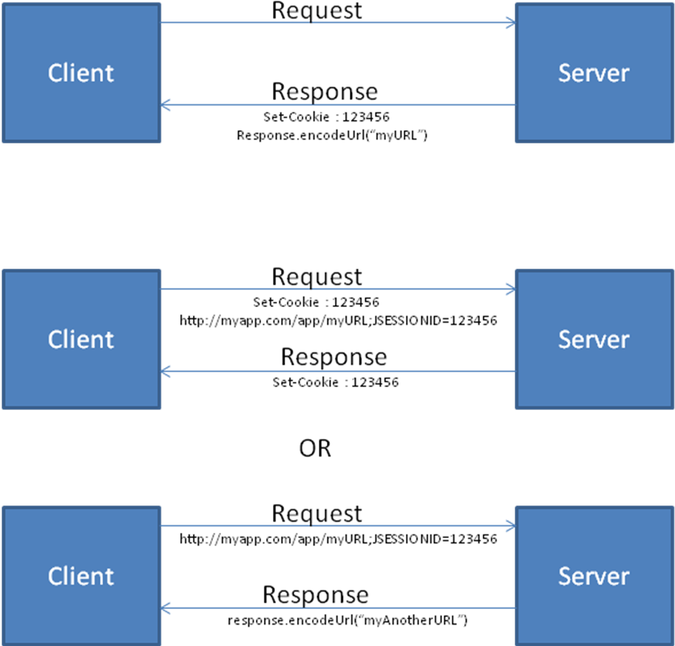

For more information refer Head First Servlets

HttpSession Events
Milestone | Methods | Event | Listener
Lifecycle | new / invalidate() | HttpSessionEvent | HttpSessionListener
Attributes | setAttribute()/add  removeAttribute()  setAttribute()/replace | HttpSessionBindingEvent | HttpSessionAttributeListener
Migration |  | HttpSessionEvent | HttpSessionActivationListener

Listener API
ServletContext | ServletContextListener | contextInitialized( ServletContextEvent )  contextDestroyed( ServletContextEvent )
ServletContext | ServlerContextAttributeListener | attributeAdded(ServletContextAttributeEvent)  attributeRemoved(ServletContextAttributeEvent)  attributeReplaced(ServletContextAttributeEvent)
ServlerRequest | ServlerRequestListener | requestInitialized(ServletRequestEvent)  requestDestroyed(ServletRequestEvent )
ServlerRequest | ServlerRequestAttributeListener | attributeAdded(ServletRequestAttributeEvent)  attributeRemoved(ServletRequestAttributeEvent)  attributeReplaced(ServletRequestAttributeEvent)
HttpSession | HttpSessionListener | sessionCreated(HttpSessionEvent)  sessionDestroyed(HttpSessionEvent)
HttpSession | HttpSessionAttributeListener | attributeAdded(HttpSessionBindingEvent)  attributeRemoved(HttpSessionBindingEvent)  attributeReplaced(HttpSessionBindingEvent)
HttpSession | HttpSessionBindingListener | valueBound(HttpSessionBindingEvent)  valueUnbound(HttpSessionBindingEvent)

Difference between HttpSessionBindingListener and HttpSessionAttributeListener

Attribute API
All below classes provide attribute API to set and get Attributes. Attributes are always String, Object pair i.e., String literals are used to hold any objects

Scopes
- Context → ServletContext
- Session → HttpSession
- Request → ServletRequest

- Context scope attributes are not thread safe.
Synchronizing the service method can save only Servlet A but doesn’t stop another Servlet B to access the attributes in context scope
Solution:
synchronized ( getServletContext () ) { }
But the problem is all servlets in a web application Servlets A, B,...Z should do this to ensure safety

- Session scope attributes are not thread safe.
Reason: If client opens another tab/browser then it is not thread safe. So synchronize HttpSession too

So Only
- Request scope attributes and local variables are thread-safe.

Techniques to create Sessions
- request.getSession( false ) ==> always returns current HttpSession, and if the request has no valid HttpSession, this method returns null.
- request.getSession( true ) ==> Returns the current HttpSession associated with this request or, returns a new HttpSession.
- request.getSession() ==> Returns the current HttpSession associated with this request, or if the request does not have a session, creates one.

How to specify a session timeout?
<get|set>MaxInactiveInterval() in Session.

Cookies getting and setting values
Reading Cookies:
Cookie[] lCookies = request.getCookies();
for( Cookie lCookie : lCookies ) {
System.out.println( lCookie.getName());
System.out.println( lCookie.getValue());
}
Writing Cookies:
Cookie userCookie = new Cookie("user", "uid1234");
response.addCookie(userCookie);
Attributes of a Cookie | Description
Name
Value
Domain | Gets/sets the domain to which cookie applies. Normally, cookies are returned only to the exact hostname that sent them. You can use this method to instruct the browser to return them to other hosts within the same domain. Note that the domain should start with a dot (e.g. .prenhall.com), and must contain two dots for non-country domains like .com, .edu, and .gov, and three dots for country domains like .co.uk and .edu.es.
MaxAge
Path | If you don't specify a path, the cookie is returned for all URLs in the same directory as the current page as well as all subdirectories. This method can be used to specify something more general. For example, someCookie.setPath("/") specifies that all pages on the server should receive the cookie. Note that the path specified must include the current directory.
Secure | The boolean value indicating whether the cookie should only be sent over encrypted (i.e. SSL) connections.
Version
Comment

What are filters?
Filters introduced in Servlet spec version 2.3 are objects that dynamically intercept request and response to transform or use the information contained in the requests or responses.
They provide the ability to encapsulate recurring tasks in reusable units. Organized developers are constantly on the lookout for ways to modularize their code. Modular code is more manageable and document able, easier to debug, and if done well, can be reused in another setting.

Filter API
The filter API is defined by the Filter, FilterChain, and FilterConfig interfaces in the javax.servlet package. You define a filter by implementing the Filter interface. A filter chain, passed to a filter by the container, provides a mechanism for invoking a series of filters. A filter config contains initialization data.
- init
- doFilter( Request, Response, FilterChain )
- destroy()
public final class HitCounterFilter implements Filter {
private FilterConfig filterConfig = null;

public void init(FilterConfig filterConfig)
throws ServletException {
this.filterConfig = filterConfig;
}

public void destroy() {
this.filterConfig = null;
}

public void doFilter(ServletRequest request,
ServletResponse response, FilterChain chain)
throws IOException, ServletException {
if (filterConfig == null)
return;
StringWriter sw = new StringWriter();
PrintWriter writer = new PrintWriter(sw);
Counter counter = (Counter)filterConfig.
getServletContext().
getAttribute("hitCounter");
writer.println();
writer.println("===============");
writer.println("The number of hits is: " +
counter.incCounter());
writer.println("===============");
// Log the resulting string
writer.flush();
filterConfig.getServletContext().
log(sw.getBuffer().toString());
...
chain.doFilter(request, wrapper);
...
// filter post-processing code
}
}
A filter can block the request in which case it populates the response using the Wrappers.
Uses:
- Authentication-Blocking requests based on user identity.
- Logging and auditing-Tracking users of a web application.
- Image conversion-Scaling maps, and so on.
- Data compression-Making downloads smaller.
- Localization-Targeting the request and response to a particular locale.
- XSL/T transformations of XML content-Targeting web application responses to more that one type of client.

What is Servlet Caching?

Structure of a WEB APP
WEBAPP
|
|__WEB-INF
| |
| |__lib
| |__classes
| |__web.xml
|
|__{Unprotected_Public_Data such as html_and_jsp_files_and_sub_directories }

What is a JSP? Lifecycle of a JSP? Explain translation of a JSP page?

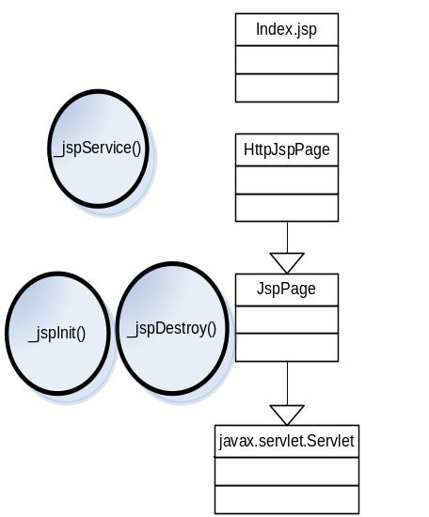Note: At runtime, index.jsp will get converted as a index.java file which will be extending container specific class which implements HttpJspPage. For eg. in Tomcat the pages will extend org.apache.jasper.runtime.HttpJspBase. The container will then know how to convert this class to a servlet at runtime. That’s the reason there is a disconnect in extensions between index.jsp and HttpJspPage interface. Also note both HttpJspPage and JspPage are interfaces.
A JSP is a text document that contains two types of text
- Static data – which can be expressed in any text-based format – HTML, SVG, WML and XML
- JSP elements – which construct dynamic contents based on Servlet technology.

When a request hits the servlet container, the container checks if the JSP’s servlet is older than the JSP page. If so it translates the JSP page to a servlet and process the request.

The page is translated and compiled once and happens during first request. To save time you can append ?jsp_precompile and compile it to save time.

What implicit objects are available in a JSP page?
Implicit objects let developers access container-provided services and resources. These objects are defined as implicit because you do not have to explicitly declare them. They are defined in every JSP page and used behind the scenes by the container whether you declare them or not -- although you cannot redeclare them. Because implicit objects are declared automatically, we need only use the reference variable associated with a given object to begin calling methods on it.
http://www.ibm.com/developerworks/java/library/j-pj2ee7.html

Implicit Object | Class or Interface | Description
page | javax.servlet.jsp.HttpJspPage | Page's Servlet instance processing the current request.
config | javax.servlet.ServletConfig | Servlet Config
pageContext | javax.servlet.jsp.pageContext | Encapsulates other implicit objects, so if you give some helper object a reference of the pageContext, the helper class can use it to get references of the other implicit objects and attributes from all scopes.
request | javax.servlet.http.HttpServletRequest | Data included with the HTTP Request
response | javax.servlet.http.HttpServletResponse | HTTP Response data, e.g. cookies
out | javax.servlet.jsp.JspWriter | Provides access to Servlet’s Output stream.
session | javax.servlet.http.HttpSession | User specific session data. Only if the page participates in a session
application | javax.servlet.ServletContext | Data shared by all application pages
exception | java.lang.Exception | If a Page is configured as Error Page

Enterprise Java Beans 2.x

EJB 2.1 Architecture
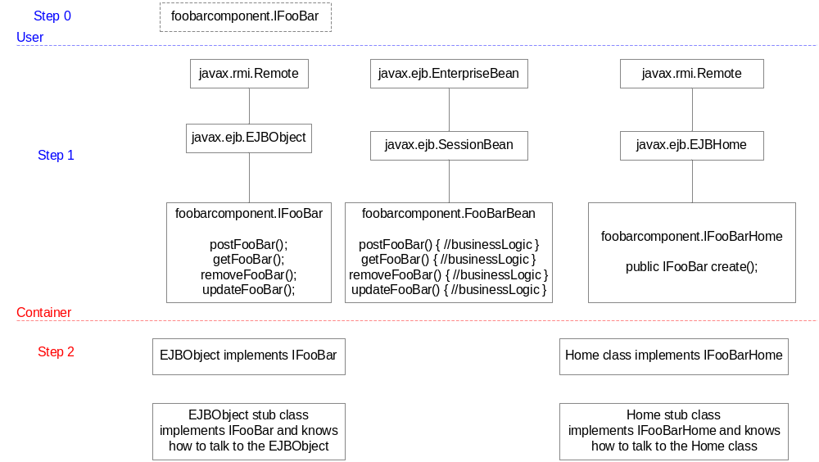

Enterprise Java Beans 3.0

Lifecycle Callback Methods

Define your own methods and assign the callback annotations

SSLB | SFSB | EB | MDB
postConstruct()  preDestroy() | postConstruct()  preDestroy()  prePassivate()  postActivate() |  | postConstruct()  preDestroy()

JDBC

Difference between "Statement", "PreparedStatement" and "CallableStatement"?
4 steps to execute a query
- parse the incoming query
- compile the query
- optimize the data acquisition path
- execute the query and get the o/p

Statement: follows all the four steps
Prepared statements: pre-does the first three and thus saves the execution time and also provides parameterization of the query. That is creating incomplete queries and substituting their values during the execution time
Statement | setQueryTimeout()
PreparedStatement
CallableStatement | Used to execute SQL Stored Procedures.

What do you mean by compiling in “PreparedStatement”?
http://db.apache.org/derby/manuals/tuning/perf34.html
This link is just to have an idea where exactly the compilation is done – to avoid confusion whether the driver [obviously not] or the database.

Different types of Drivers?
- JDBC-ODBC Bridge [ Translation = 3 ]
- Native API Partly Java Code Driver [ Translation = 2 ]
- Net-Protocol Fully Java Technology enabled Driver [ Translation = 3 ]
- Native-Protocol Fully Java Technology enabled Driver [ Translation = 1 ]
http://en.wikipedia.org/wiki/JDBC_driver

JDBC driver performance depends on a number of issues
- Quality of driver code.
- Size of the driver code
- Database server and its load.
- Network Topology
- Number of times he request is translated to a different API.

How to load a JDBC driver?
The DriverManager class maintains a list of Driver classes that have registered themselves by calling the method DriverManager.registerDriver. All Driver classes should be written with a static section (a static initializer) that creates an instance of the class and then registers it with the DriverManager class when it is loaded. Thus, a user would not normally call DriverManager.registerDriver directly; it should be called automatically by a Driver class when it is loaded. A Driver class is loaded, and therefore automatically registered with the
DriverManager, in one of two ways:

- By calling the method Class.forName. This explicitly loads the driver class. Since it does not depend on any external setup, this way of loading a driver is the recommended one for using the DriverManager framework. The following code loads the class acme.db.Driver

Class.forName("acme.db.Driver");

If acme.db.Driver has been written so that loading it causes an instance to be created and also calls DriverManager.registerDriver with that instance as the parameter (as it should do), then it is in the DriverManager's list of drivers and available for creating a connection.

- By adding the Driver class to the java.lang.System property jdbc.drivers. This is a list of driver classnames, separated by colons that the DriverManager class loads. When the DriverManager class is initialized, it looks for the system property "jdbc.drivers," and if the user has entered one or more drivers, the DriverManager class attempts to load them. The following code illustrates how a programmer might enter three driver classes in ~/.hotjava/properties (HotJava loads these into the system properties list on startup):
jdbc.drivers=foo.bah.Driver:wombat.sql.Driver:bad.test.ourDriver

The first call to a DriverManager method will automatically cause these driver classes to be loaded.

Note that this second way of loading drivers requires a preset environment that is persistent. If there is any doubt about that being the case, it is safer to call the method Class.forName to explicitly load each driver. This is also the right method to use to bring in a particular driver since once the DriverManager class has been initialized, it will never recheck the jdbc.drivers property list.

In both of these cases, it is the responsibility of the newly loaded Driver class to register itself by calling DriverManager.registerDriver. As mentioned, this should be done automatically when the class is loaded.

For security reasons, the JDBC management layer will keep track of which class loader provided which driver. Then when the DriverManager class is opening a connection, it will use only drivers that come from the local file system or from the same class loader as the code issuing the request for a connection.

Connection lConnection = DriverManager.getConnection(url,"dba","sql");
Statement lStatement = lConnection.createStatement();

Features in JDBC2.0, JDBC 3.0 and JDBC 4.0?
JDBC 2.0
- RowSet – A Java Bean component capable of having listeners
  - CachedRowSet
  - JDBCRowSet
  - WebRowSet
- Batch Update Facility – Statement.addBatch( updateSQLStmtStr );
- Scrollable ResultSet

JDBC 3.0
- SavePoint Introduction
- With JDBC 2.0 connection pooling, there were no tuning capabilities. Either you used connection pooling or you didn't. With 3.0, there is access to a finer level of granularity available to control the characteristics of the connection pool.
- Statement Pooling
- Ability to return PseudoColumns specific to the DB [getGeneratedKeys() ]
- Update of SQL99 Blob and Clob
- Handling multiple Open ResultSet Objects.
http://www.datadirect.com/developer/jdbc/topics/jdbc30/index.ssp

JDBC 4.0
- Auto-loading of JDBC Driver class – uses Java SE Service Provider mechanism
- RowId Interface support
- Annotation-Based SQL Queries
- Enhanced Exception Handling
  - Non-Transient Exceptions
  - Transient Exceptions
- We can use enhanced for loop for Iterable SQLException
http://www.onjava.com/pub/a/onjava/2006/08/02/jjdbc-4-enhancements-in-java-se-6.html

What is Transaction? Why are they important?
http://www.subbu.org/articles/transactions/NutsAndBoltsOfTP.html

How to perform Transaction in JDBC vs JTA?
Unlike Connection objects produced by the DriverManager, a Connection object produced by a DataSource object will have its auto-commit mode disabled by default. A standard implementation of a DataSource object, on the other hand, will produce Connection objects that are exactly the same as those produced by the DriverManager class.

When a Connection object is part of a distributed transaction, a transaction manager determines when the methods commit or rollbacks are called on it. Thus, when a Connection object is participating in a distributed transaction, an application should not do anything that affects when a connection begins or ends, such as calling the methods Connection.commit or Connection.rollback, or turning on the connection's auto-commit mode. These would interfere with the transaction manager's handling of the distributed transaction.

What is a "SavePoint"?
An SQL savepoint represents the state of data and schemas at a particular point in time within a unit of work. SQL statements exist to set a savepoint, release a savepoint, and restore data and schemas to the state that the savepoint represents.
The DB2 Universal JDBC Driver supports the following methods for using savepoints:
- Sets a savepoint. These methods return a Savepoint object that is used in later releaseSavepoint or rollback operations.
Connection.setSavepoint() or Connection.setSavepoint(String name)
When you execute either of these methods, DB2^{(R)} executes the form of 4 the SAVEPOINT statement that includes ON ROLLBACK RETAIN CURSORS.
- Releases the specified savepoint, and all subsequently established savepoints.
Connection.releaseSavepoint(Savepoint savepoint)
- Rolls back work to the specified savepoint
Connection.rollback(Savepoint savepoint)
- Indicates whether a data source supports savepoints
DatabaseMetaData.supportsSavepoints()

Difference between "DriverManager" and "DataSource"?
http://java.sun.com/j2se/1.4.2/docs/guide/jdbc/getstart/datasource.html

- Portability - Application code is no mode vendor lock in.
- Ease of Maintenance -
- Performance - Make use of Connection Pooling if available in DataSource
- Distributed Transactions - Make use of Transactions if available in DataSource

What are the various transaction levels in DB?
Transaction Anomaly
Dirty Reads | A dirty read occurs when a transaction reads data from a row that has been modified by another transaction, but not yet committed. | Transaction A begins.  UPDATE employee SET salary = 31650  WHERE empno = '000090'  Transaction B begins.  SELECT * FROM employee  (Transaction B sees data updated by transaction A. Those updates have not yet been committed.)
Non Repeatable Reads | Non-repeatable reads happen when a query returns data that would be different if the query were repeated within the same transaction. Non-repeatable reads can occur when other transactions are modifying data that a transaction is reading. | Transaction A begins.  SELECT * FROM employee  WHERE empno = '000090'  Transaction B begins.  UPDATE employee SET salary = 30100  WHERE empno = '000090'  (Transaction B updates rows viewed by transaction A before transaction A commits.) If Transaction A issues the same SELECT statement, the results will be different.
Phantom Reads | Records that appear in a set being read by another transaction. Phantom reads can occur when other transactions insert rows that would satisfy the WHERE clause of another transaction's statement. | Transaction A begins.  SELECT * FROM employee  WHERE salary > 30000  Transaction B begins.  INSERT INTO employee  (empno, firstnme, midinit,  lastname, job,  salary) VALUES ('000350', 'NICK',  'A','GREEN','LEGAL COUNSEL',35000)  Transaction B inserts a row that would satisfy the query in Transaction A if it were issued again.

Isolation Level | Table-Level Locking Schema | Row-Level Locking Schema
TRANSACTION_READ_UNCOMMITTED | Dirty Reads, non repeatable reads and phantom reads possible | Dirty Reads, non repeatable reads and phantom reads possible
TRANSACTION_READ_COMMITTED | Non repeatable reads and phantom reads possible | Non repeatable reads and phantom reads possible
TRANSACTION_REPEATABLE_READ | Phantom reads not possible because entire table is locked | Phantom reads possible
TRANSACTION_SERIALIZABLE | None | None

Difference between “Time” and “Timestamp”?
Good example of the dreaded Implementation Inheritance.

Why is autocommit mode always set off?
Auto commit mode is almost always inappropriate in an application, however. An application doesn’t perform ad hoc or any unplanned queries; instead, it executes a preplanned sequence of related operations (which are, by definition, never ad hoc). Therefore, Hibernate automatically disables auto commit mode as soon as it fetches a connection (from a connection provider—that is, a connection pool). If you supply your own connection when you open the Session, it’s your responsibility to turn off auto commit!

- How to stop a Statement execution in the middle without calling close().
Set a time out by calling setQueryTimeout();

Database

Database and SQL

SQL Syntax:
CREATE | TABLE simpletable  ( column1 varchar(15),  column2 varchar(15),  column3 varchar(15)  );
DROP
SELECT | $Column_Name FROM $Table_Name WHERE $Column_Name >= ‘XX’;
UPDATE | $Table_Name SET $Column_Name = ‘value’ WHERE $Column_Name = ‘XX’;
INSERT | INTO $Table_Name ($Field_Names) VALUES($Field_Values);
DELETE | FROM $Table_Name WHERE $Column_Name = 'XX' AND $Column_Name = ’XX’;
USE

What are the different types of Joins?
http://en.wikipedia.org/wiki/Join_(SQL)
CREATE TABLE a_table(a_id INTEGER,a_value VARCHAR(255));

CREATE TABLE b_table(b_id INTEGER,b_value VARCHAR(255));

INSERT INTO a_table (a_id, a_value) VALUES (1,'A');
INSERT INTO a_table (a_id, a_value) VALUES (2,'B');
INSERT INTO a_table (a_id, a_value) VALUES (3,'C');

INSERT INTO b_table (b_id, b_value) VALUES (1,'A');
INSERT INTO b_table (b_id, b_value) VALUES (3,'C');
INSERT INTO b_table (b_id, b_value) VALUES (4,'D');
INSERT INTO b_table (b_id, b_value) VALUES (5,'E');

  A_ID | A_VAL
  1 | a
  2 | b
  3 | c
  B_ID | B_VAL
  1 | A
  3 | C
  4 | D
  5 | E

- CROSS JOIN (Cartesian product) is the simplest join n X m

select * from a_table CROSS JOIN b_table;
A_ID | A_VAL | B_ID | B_VAL
1 | A | 1 | A
1 | A | 3 | C
1 | A | 4 | D
1 | A | 5 | E
2 | B | 1 | A
2 | B | 3 | C
2 | B | 4 | D
2 | B | 5 | E
3 | C | 1 | A
3 | C | 3 | C
3 | C | 4 | D
3 | c | 5 | E

- INNER JOIN (sometimes called the "EQUI-JOIN") where tables are combined based on a common column

select * from a_table, b_table where a_id = b_id;
select * from a_table INNER JOIN b_table on A_id = B_id;
A_ID | A_VAL | B_ID | B_VAL
3 | C | 3 | C
1 | A | 1 | A

- OUTER JOIN, which involves combining all rows of one table with only matching, rows from the other table
IN ORACLE OUTER JOIN behaves same like INNER JOIN so specify the left and right

select * from a_table LEFT OUTER JOIN b_table on a_id = b_id;
A_ID | A_VAL | B_ID | B_VAL
3 | C | 3 | C
1 | A | 1 | A
2 | B | (null) | (null)

select * from a_table RIGHT OUTER JOIN b_table on a_id = b_id;
A_ID | A_VAL | B_ID | B_VAL
3 | C | 3 | C
1 | A | 1 | A
(null) | (null) | 4 | D
(null) | (null) | 5 | E

select * from a_table FULL OUTER JOIN b_table on a_id = b_id;
A_ID | A_VAL | B_ID | B_VAL
3 | C | 3 | C
1 | A | 1 | A
2 | B | (null) | (null)
(null) | (null) | 4 | D
(null) | (null) | 5 | E

- SELF JOIN that is a table joined to itself.
http://www.onlamp.com/pub/a/onlamp/2001/07/12/aboutSQL.html
CREATE TABLE emp(emp_id INTEGER,emp_name VARCHAR(255), mgr_id INTEGER);

INSERT INTO emp (emp_id,emp_name) VALUES (61,'Sue Smith');
INSERT INTO emp (emp_id,emp_name, mgr_id) VALUES (62, 'David Jones', 61);
INSERT INTO emp (emp_id,emp_name, mgr_id) VALUES (63, 'Troy Parker', 61);
INSERT INTO emp (emp_id,emp_name, mgr_id) VALUES (64, 'Claire Smith-Jones', 63);
INSERT INTO emp (emp_id,emp_name, mgr_id) VALUES (65, 'Grover Rivers', 63);

SELECT E1.emp_name AS employee,
E2.emp_name AS manager
FROM
emp AS E1
INNER JOIN
emp AS E2
ON E1.mgr_id = E2.emp_id
  emp_id | emp_name | mgr_id
  61 | Sue Smith | (null)
  62 | David Jones | 61
  63 | Troy Parker | 61
  64 | Claire Smith-Jones | 63
  65 | Grover Rivers | 63
  employee | manager
  David Jones | Sue Smith
  Troy Parker | Sue Smith
  Claire Smith-Jones | Troy Parker
  Grover Rivers | Troy Parker

Explain advantage of using Outer-Joins and Self-Joins

How to write a sub query?
SELECT column_name AS temp_name FROM table_name
WHERE column_name IN
( SELECT DISTINCT column_name FROM table_name )

SubQueries vs Joins?
Though written as subquery it will get transformed to inline query but again it depends on the version of the oracle which allows this transformation. The performance will be good only in the inline query. And more over the use of DISTINCT clause which is used to eliminate unintended duplicate rows is provided in inline queries

Explain Normalization with examples?
Chef Number
Chef Name
Restaurant Code
Restaurant Name
Restaurant Location
Food Item ID
Food Item Name
Food Item Learned
Food Item Skill Level
Tappan Style Cooking – 4th Normal Form
Cuisine Category { Asian|African}
Cuisine Sub Category {Japanese|Indian|Chinese|SriLankan}{SouthAfrican|CentralAfrican}

http://www.marcrettig.com/poster/rettigNormalizationPoster.pdf

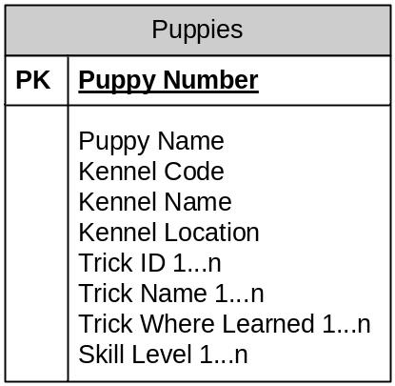

NORMAL FORM | DESCRIPTION | APPLICATION
Eliminate  Repeating  Groups | Make a separate table for set of related attributes and give a primary key for each table. | 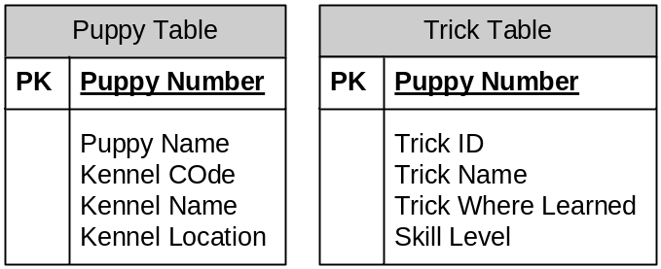
Eliminate  Redundant  Data | If an attribute depends only on part of a multi-valued Key remove it to a new table | 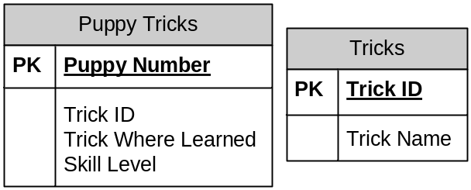  Updates Anomaly: Updates are Hard – Changing Trick ID for a given Trick Name will involve update in all the columns  Delete Anomaly [if the last known puppy with a new trick dies - the trick is lost]
Eliminate Columns  Not Dependent on KEY | If attributes do not contribute to a description of the key, remove them to a separate table | 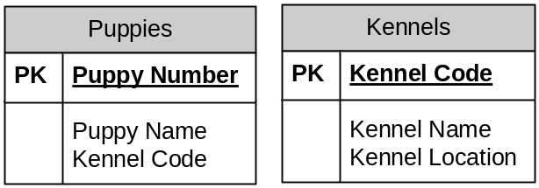  Same motivation like 2nd Normal form to avoid Update and Delete Anomalies.  Eg: If there are no puppies currently available from Daisy Puppy Farm, then with the current design Daisy Puppy Farm kennel will be lost.
Isolate Independent Multiple  Relationships | No table may contain two or more 1 to n or n to m relationships that are no longer directly related | 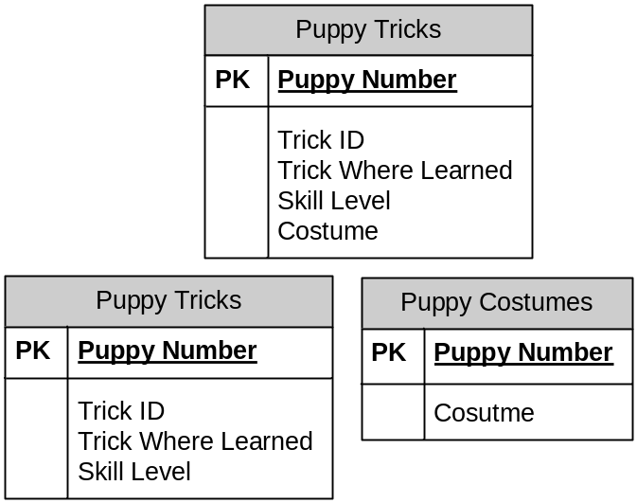
Isolate  Semantically Related Multiple Relationships |  | 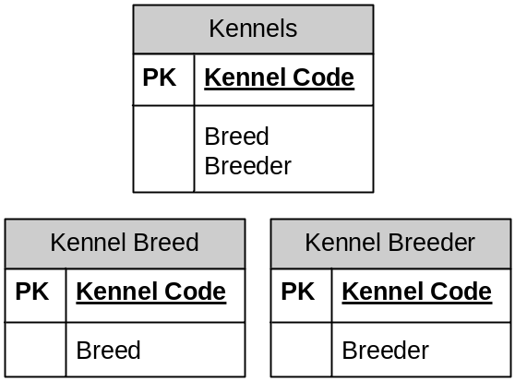  Suppose you want to add Breeds 1, 2 and 3 to for every Breeder A, B and C.  Previous design will involve 9 inserts while later will involve only 6 inserts.  Inserts and Updates are Reduced.

Explain Denormalization with examples?

- Denormalization is the process of attempting to optimize the read performance of a database by adding redundant data or by grouping data
- Denormalization may solve one part of dealing with performance, but it creates possible performance problems in several other areas. Total performance impact must be evaluated. Furthermore, data integrity is at (high) risk.
- If you have a much higher demand on reporting functions, consider denormalization of your database into a separate data warehouse, which is periodically updated with summary information, preferably during night time, and leave your running database normalized for flexibility and data integrity. A clean, normalized database should always deliver good performance, as well as preserve data integrity.
http://publib.boulder.ibm.com/infocenter/dzichelp/v2r2/index.jsp?topic=/com.ibm.db29.doc.admin/db2z_denormalization.htm

Data Integrity
Required  Data | Some columns are specified as NULL and NOT NULL
Validity  Checking | Every column in a database has a domain, a set of data values that are legal for that column. E.g.: Some columns can have values in a range 101-999
Entity  Integrity | The primary key of a table must contain a unique value in each row.
Referential  Integrity | A foreign key in a relational database links each row in the child table containing the foreign key to the row of the parent table containing matching primary key.  Unlike Primary Key Foreign Keys are allowed to have null values. Eg: A newly joined Employee may not have been assigned a Manager.
Other  Data  Relationships | Real world can have additional constraints. E.g.: A discount should not exceed a maximum limit.
Business  Rules | Updates to a business rule may be constrained.
Consistency | An INSERT in one table can cause an UPDATE in another table.  Eg: Adding an Order can increase a column value in Sales table.

What are the different types of constraints?
Constraints are rules that can be imposed to maintain the data integrity of any data store.
PRIMARY KEY | CONSTRAINT $Constraint_Name PRIMARY KEY ( $Column_Name )
REFERENCES (Oracle)/  FOREIGN KEY | CONSTRAINT $Constraint_Name FOREIGN KEY ($Column_Name) REFERENCES $Table_Name ( $Column_name )
NOT NULL | CONSTRAINT $Constraint_Name NOT NULL ($Column_Name )
UNIQUE | CONSTRAINT $Constraint_Name UNIQUE ($Column_Name
CHECK (Oracle) | CONSTRAINT $Constraint_Name  CHECK ( $Column_Name BETWEEN 100 and 9999 )

What are Views?
A virtual table defined in the database, whose contents are defined by a query. Unlike tables it doesn’t exist in database. The rows and columns are visible only due to the Query Result.

CREATE | CREATE VIEW $View_Name AS $Select_Statement>;
ALTER | ALTER VIEW $View_Name [($column_list)] AS $Select_Statement;
DROP | DROP VIEW [IF EXISTS] $View_Name [,$View_Name]

Simple View - Rows and Columns are created on the fly.
Complex Views – Materialized views: a temporary table is created by the DBMS and all query operations are carried out on this temporary table. It is then discarded after use.

Advantages:
- Security – Users can be given access to the database only through views.
- Query Simplicity - A View can draw data from multiple tables and present it as a single table turning multi-table queries to a single table query.
- Structural Simplicity – Gives a personalized view of the database structure, presenting the database as a set of virtual tables that makes sense for the user.
- Insulation from Change – A view can present a consistent, unchanged image of the structure of the database, even if the underlying source tables are split, restructured or renamed.
- Data Integrity – If data is accessed through a view DBMS provides auto check for integrity constraints.
Disadvantages:
- Performance – Views create the appearance of a table, but the DBMS still translates the queries against the view into queries against the underlying source tables. If the view is defined by a complex multi-table query even a single query against the view becomes a complicated join and takes long time to complete.
- Update Restrictions – When a user tries to update rows of a view, the DBMS must translate the request to an update on rows of the source tales. This is possible for simple views but for more complex views updates are not possible. They are read only.
Horizontal Views – All columns participate in the view but only some rows are visible through the view.
Vertical Views – Restriction is placed on certain columns of a table.
Both of the above are only concepts. There is no notion of horizontal or vertical in SQL syntax.

Transactions and Locking
Database Level Locking | Allows only one Transaction to happen at any time.
Table Level Locking | Database locks the tables involved in Transaction.
Page Level Locking | Database locks individual blocks of data (pages) from the disk as they are accessed by a transaction.
Row Level Locking | For certain applications, the overhead of row level locking – maintenance and keeping track of locks on variable-length pieces of the database (rows) rather than fixed sized pages is greater than the performance gains.  So most databases address this problem by promoting many individual row level locks to page or table level when the number of row levels reaches a certain limit.
Item Level Locking | Theoretically possible. But no commercial database avails this feature.

Locking Schemes
Shared Lock – Used by DBMS when a transaction wants to read data from the database. Another concurrent transaction can also acquire a shared lock on the same data, allowing the other transaction to also read the data.
Exclusive Lock – Used by DBMS when a transaction wants to update data in the database. No other transaction can acquire any type of lock on the data while another transaction is executing.
 |  | Transaction B
 |  | Unlocked | Shared Lock | Exclusive Lock
Transaction A | Unlocked | OK | OK | OK
Transaction A | Shared Lock | OK | OK | NO
Transaction A | Exclusive Lock | OK | NO | NO

Transaction Isolation Levels
Isolation Levels | Description
Read Uncommitted | Transaction can read uncommitted data | Dirty Reads  Non-Repeatable Reads  Phantom Reads
Read Committed | Transaction cannot read uncommitted data | Non-Repeatable Reads  Phantom Reads
Repeatable Read | Transaction cannot change data that is being read by a different transaction | Phantom Reads
Serializable | Transaction has exclusive read and update privileges.

STORED PROCEDURES/ FUNCTIONS
 | Stored Procedures | Functions
Return | Multiple OUT Parameters | Single Return Value
Usage | PL/SQL using Execute or  begin <> end; | In SQL Queries
 | Compiled once and called each time | Compile each time they are called

SPL – Stored Procedure Language
As SQL was not envisioned as a Computer programming language it needed the following capabilities.
- Conditional Execution
- Looping
- Block Structure
- Named Variables
- Named Procedures
Stored Procedures were first introduced by Sybase.
Advantages:
- Runtime Performance – Most SPs are compiled into an internal representation that can be executed very efficiently by the DBMS.
- Reusability – Can be called by many different applications
- Reduced Network Traffic - If a logical transaction requires 6 SQL operations, 6 network roundtrips are required. With a Stored Procedures the sequence of 6 SQL operations could be programmed into a procedure and stored in a Database.
- Security – With SP you can give permissions to a user who doesn’t have permission for the underlying tables. So by giving an execute SP only permission more tighter security is gained.
- Encapsulation –
- Simplicity – A call to a SP is easier to understand than a bunch of SQL statements.
- Business Rules Enforcement – Good candidates for enforcing business level integrity
- Can handle Exceptions

CREATE PROCEDURE $MY_PROCEDURE
…
END PROCEDURE
DROP PROCEDURE $MY_PROCEDURE
EXECUTE MY_PROCEDURE( ‘$MY_PARAMETER1’, ‘$MY_PARAMETER2’, ‘$MY_PARAMETER3’ )
FUNCTIONS
CREATE OR REPLACE FUNCTION delete_emps(dept in number) return number as
BEING
delete emp where emp.deptno = dept;
return sql%rowcount;
END;
SQL> var rowsdel number
SQL> exec :rowsdel := delete_emps(30);
PL/SQL procedure successfully completed.
SQL> print rowsdel
ROWSDEL

TRIGGERS
For any event that causes a change in the contents of a table, a user can specify an associated action that the DBMS should carry out. The three events that can trigger an action are attempts to INSERT, DELETE or UPDATE.

CREATE TRIGGER NEWORDER
ON ORDERS
FOR INSERT
AS UPDATE SALESREPS
…
The above trigger will be invoked whenever an INSERT is attempted on the Order tables. The remainder of the definition (after AS) defines the action of the Trigger.

Uses: An alternative way to implement Referential Integrity constraints provided by the Foreign and Primary Keys.

CURSORS

Need For Cursors
It is necessary because many programming languages suffer from impedance mismatch. Programming languages are often procedural and do not offer any mechanism for manipulating whole result sets at once. Therefore, the rows in a result set must be processed sequentially by the application. In this way, a cursor can be thought of as an iterator over the collection of rows in the result set.

- For every SQL statement execution certain area in memory is allocated. PL/SQL allow you to name this area. This private SQL area is called context area or cursor. A cursor acts as a handle or pointer into the context area. A PL/SQL program controls the context area using the cursor. Cursor represents a structure in memory and is different from cursor variable.
- When you declare a cursor, you get a pointer variable, which does not point any thing. When the cursor is opened, memory is allocated and the cursor structure is created. The cursor variable now points the cursor. When the cursor is closed the memory allocated for the cursor is released.
- Cursors allow the programmer to retrieve data from a table and perform actions on that data one row at a time. There are two types of cursors implicit cursors and explicit cursors.
IMPLICIT CURSORS
Implicit cursors are simple SELECT statements and are written in the BEGIN block (executable section) of the PL/SQL. Implicit cursors are easy to code, and they retrieve exactly one row. PL/SQL implicitly declares cursors for all DML statements. The most commonly raised exceptions here are NO_DATA_FOUND or TOO_MANY_ROWS.

SELECT ename, sal INTO ena, esa FROM EMP WHERE EMPNO = 7844;

EXPLICIT CURSORS
Explicit cursors are used in queries that return multiple rows. The set of rows fetched by a query is called active set. The size of the active set meets the search criteria in the select statement. Explicit cursor is declared in the DECLARE section of PL/SQL program.
CURSOR <cursor-name> IS <select statement>

DECLARE
CURSOR emp_cur IS SELECT ename FROM EMP;
BEGIN
----
---
END;

http://www.exforsys.com/tutorials/oracle-9i/oracle-cursors.html

Note: SQL1 Cursors support only Sequential Motion.

Scroll Cursors: Cursors may be declared as being scrollable or not. The scrollability indicates the direction in which a cursor can move. A non-scrollable cursor is also known as forward-only. Each row can be fetched at most once, and the cursor automatically moves to the immediately following row. A fetch operation after the last row has been retrieved positions the cursor after the last row and returns SQLSTATE 02000 (SQLCODE +100).

A scrollable cursor can be positioned anywhere in the result set using the FETCH SQL statement. The keyword SCROLL must be specified when declaring the cursor. The default is NO SCROLL, although different language bindings like JDBC may apply different default.

DECLARE $Cursor_Name sensitivity SCROLL CURSOR FOR SELECT ... FROM ...

The target position for a scrollable cursor can be specified relative to the current cursor position or absolute from the beginning of the result set.

FETCH [ NEXT | PRIOR | FIRST | LAST ] FROM $Cursor_Name

FETCH ABSOLUTE n FROM $Cursor_Name

FETCH RELATIVE n FROM $Cursor_Name

Disadvantages:
- Fetching a row from the cursor may result in a network round trip each time. This uses much more network bandwidth than would ordinarily be needed for the execution of a single SQL statement like DELETE.
- Cursors allocate resources at the server, for instance locks, packages, processes, temporary storage, etc. If a cursor is not properly closed (deallocated), the resources will not be freed until the SQL session (connection) itself is closed.

What cursor type do you use to retrieve multiple recordsets?

What are HINTS?
Oracle Hints is an Oracle Database feature through which a developer makes decisions usually reserved for the optimizer. Developers use hints to specify things such as join order for a join statement, or the optimization approach of an SQL call.

What are sequences?
- To build calendar-type applications and leave-day/business-day calculations (tables with ranges of dates)
- Sales fact tables (tables with ranges of numbers or dates)
- Creating volume data for volume testing of applications (tables with ranges of numbers, dates or alpha-numeric values)
- Motivation - Use the MAX function to determine the currently used maximum value and then increment that value for the new row - Tedious

Tradeoffs with having indexes?
http://www.odetocode.com/Articles/70.aspx
CREATE INDEX [IDX_UnitPrice] ON Products (UnitPrice)
- The database takes the columns specified in a CREATE INDEX command and sorts the values into a special data structure known as a B-tree. A B-tree structure supports fast searches with a minimum amount of disk reads, allowing the database engine to quickly find the starting and stopping points for the query we are using.

Modeling m-n relationship in Database
http://www.alachisoft.com/articles/m-n_relationships.html

Difference between "drop", "truncate" and "delete" ➔DeTD
OPERATION | DESCRIPTION | COMMIT & ROLLBACK | TRIGGER
DELETE  [DML] | The DELETE command is used to remove rows from a table. A WHERE clause can be used to only remove some rows. If no WHERE condition is specified, all rows will be removed. After performing a DELETE operation you need to COMMIT or ROLLBACK the transaction to make the change permanent or to undo it. Note that this operation will cause all DELETE triggers on the table to fire. | Y | Y
TRUNCATE  [DDL] | TRUNCATE removes all rows from a table. The operation cannot be rolled back and no triggers will be fired. As such, TRUNCATE is faster and doesn't use as much undo space as a DELETE. | N | N
DROP  [DDL] | The DROP command removes a table from the database. All the tables' rows, indexes and privileges will also be removed. No DML triggers will be fired. The operation cannot be rolled back. | N | N
DROP and TRUNCATE are DDL commands, whereas DELETE is a DML command. Therefore DELETE operations can be rolled back (undone), while DROP and TRUNCATE operations cannot be rolled back.

DECODE in ORACLE
if ( 1 == 1 )
show sysdate
else
show sysdate-1

select decode( 1, 1, sysdate, sysdate-1) from dual;

Why can a “groupby” and “orderby” clauses can be expensive to compute?
GroupBy – used to combine database records with identical values in a specified field into a single record, usually for the purposes of calculating some sort of aggregate function.
http://www.linuxdevcenter.com/pub/a/linux/2001/02/23/aboutSQL.html

EmployeeID | SalesAmount | SalesDate |  | EmployeeID | SUM(SalesAmount)
1 | 150 | 1/1/01 |  | 1 | 200
1 | 50 | 1/1/01 |  | 2 | 100
2 | 100 | 1/1/01 |  | 3 | 300
3 | 300 | 1/1/01
3 | 0 | 1/1/01
SELECT EmployeeID, SUM(SalesAmount) GROUP BY EmployeeID

OrderBy - for display purpose
http://www.linuxdevcenter.com/pub/a/linux/2001/02/13/aboutSQL.html
SELECT * from employee ORDER BY EmployeeID

Difference between "Primarykey" and "Aggregatekey"?
primary key : the column which is used for thr unique identification of a record from a table is called the primary key
alternate/aggregate key : a column which is used for unique identification but not a primary key is called the alternate key

Difference between "where" and "having"?
- HAVING clause is usually used with Group By clause although it can be used without it too.
- HAVING is just an additional filter to WHERE clause.
- WHERE clause applies to the individual rows whereas HAVING clause is used to test some condition on the group (usually with aggregate methods) rather than on individual rows.
- HAVING can be used only with the SELECT statement. HAVING is typically used in a GROUP BY clause. When GROUP BY is not used, HAVING behaves like a WHERE clause.
SELECT max(state) from States HAVING count(State) > 60

Difference between "varchar" and "varchar2"?

 | Char | varchar | varchar2
Column Creation | Fixed Length | Variable Length | Variable Length
Length | 0-255 | 0-65,535
Padding | Right Padded with spaces
Bytes |  | Values are stored as a one-byte or two-byte length prefix plus data.

Value | CHAR(4) | Storage Required | VARCHAR(4) | Storage Required
‘’ | ‘ ‘ | 4 bytes | ‘’ | 1 byte
‘ab’ | ‘ab ‘ | 4 bytes | ‘ab’ | 3 bytes
‘abcd’ | ‘abcd’ | 4 bytes | ‘abcd’ | 5 bytes
‘abcdefgh’ | ‘abcd’ | 4 bytes | ‘abcd’ | 5 bytes

Difference between "translate" and "replace"?

How to remove duplicate rows from a table?
http://www.orafaq.com/faq/how_does_one_eliminate_duplicates_rows_from_a_table

What are the large objects supported by Oracle?

Storing XML
http://www.xml.com/pub/a/2001/06/20/databases.html

Oracle | oracle.xml.sql.query.OracleXMLQuery.getXMLString();  oracle.xml.sql.query.OracleXMLQuery.getXMLDOM();
XML:DB API (XAPI)

BLOB vs CLOB for XML

How to find the database name from SQL*PLUS command prompt?
Select * from mySchema.tables

Query to display all table names from a database?

How to copy structure of a table without copying its data?

How to convert RAW datatype to Text?

What is OCI?

What is “index covering” of a Query?

What is PL/SQL?

What is the use of ANALYZing the table?

Difference between "NULL" in C and "NULL” in Oracle ?

What is Pro*C?

Design Patterns

Design Patterns

Benefits of Design Patterns?
Capture expertise and make it accessible to non-experts in a standard form
Facilitate communication among developers by providing a common language
Make it easier to reuse successful designs and avoid alternatives that diminish reusability
Facilitate design modifications
Improve design documentation
Improve design understandability

Abstraction/Encapsulation/Information Hiding

Use of Accessors and Mutators instead of public access:
public void setSpeed(double newSpeed) {
if (newSpeed < 0) {
sendErrorMessage(...);
newSpeed = Math.abs(newSpeed);
}
speed = newSpeed;
}

If users of your class accessed the fields directly, then they would each be responsible for checking constraints

Difference between "Inheritance" and "Composition"?
Both have common goal - code reuse.
Problem with Inheritance:
Inheriting behavior by sub classing makes the behavior statically set at compile time.
Also all subclasses inherit the same behavior.
When you establish an inheritance relationship between two classes, you get to take advantage of dynamic binding and polymorphism.
- Inheritance is also sometimes said to provide "weak encapsulation" because if you have code that directly uses a subclass, such as Apple, that code can be broken by changes to a super class, such as Fruit. One of the ways to look at inheritance is that it allows subclass code to reuse superclass code. For example, if Apple doesn't override a method defined in its superclass Fruit, Apple is in a sense reusing Fruit's implementation of the method. But Apple only "weakly encapsulates" the Fruit code it is reusing, because changes to Fruit's interface can break code that directly uses Apple. – Eg: changing a return type in Fruit class will need all subclasses which override this method to change.

With Composition, it can be done dynamically at runtime.
- Subclass to get type matching. Don’t use inheritance to get the behavior.
- Use composition to get the behavior at runtime by properly implementing the desired behavior interface.

Advantages:
- Chances of introducing bugs into the existing code or causing unintended side effects in the pre-existing code gets much reduced.
- Doesn’t change the existing code.
- Code that depends only on the front-end interface still works, so long as the front-end interface remains the same.
- Extending a HashSet compared to implementing Set interface. In the later case if I use composition I can contain any Set Implementation – need not just HashSet.
- The class itself is a Set. Not a specialized version of Set

Composition | Inheritance
Contained objects are accessed by the containing class solely through their interfaces
"Black-box" reuse, since internal details of contained objects are not visible | "White-box" reuse, since internal details of superclasses are often visible to  Subclasses
Good encapsulation | Breaks encapsulation, since it exposes a subclass to implementation details  of its supe rclass
Fewer implementation dependencies
Each class is focused on just one task | Subclasses may have to be changed if the implementation of the superclass  Changes.
The composition can be defined dynamically at run-time through objects acquiring references to other objects of the same type | Implementations inherited from superclasses can not be changed at runtime
Resulting systems tend to have more objects | New implementation is easy, since most of it is inherited
Interfaces must be carefully defined in order to use many different objects as composition blocks | Easy to modify or extend the implementation being reused

When to use Inheritance?
http://userpages.umbc.edu/~tarr/dp/lectures/OOPrinciples.pdf

Subclass Should be specialization not a Role | A subclass expresses "is a special kind of" and not "is a role played by a"
Should never Transmute | An instance of a subclass never needs to become an object of another class
Always extend never  Try to override | A subclass extends, rather than overrides or nullifies, the responsibilities of its superclass
Never extend a Utility Class | A subclass does not extend the capabilities of what is merely a utility class
 | For a class in the actual Problem Domain, the subclass specializes a role, transaction or device

Implementation inheritance vs Interface inheritance
Implementation Inheritance (Class Inheritance) - an object's implementation is defined in terms of another's objects implementation
Interface Inheritance (Sub typing) - describes when one object can be used in place of another object

Open Closed Principle:
http://www.oodesign.com/open-close-principle.html
A clever application design and the code writing part should take care of the frequent changes that are done during the development and the maintaining phase of an application. Usually, many changes are involved when a new functionality is added to an application. Those changes in the existing code should be minimized, since it's assumed that the existing code is already unit tested and changes in already written code might affect the existing functionality in an unwanted manner.

The Open Close Principle states that the design and writing of the code should be done in a way that new functionality should be added with minimum changes in the existing code. The design should be done in a way to allow the adding of new functionality as new classes, keeping as much as possible existing code unchanged.
Intent

Software entities like classes, modules and functions should be open for extension but closed for modifications.

// Open-Close Principle - Bad example  class GraphicEditor {  public void drawShape(Shape s) {  if (s.m_type==1)  drawRectangle(s);  else if (s.m_type==2)  drawCircle(s);  }  public void drawCircle(Circle r) {....}  public void drawRectangle(Rectangle r) {....}  }  class Shape {  int m_type;  }  class Rectangle extends Shape {  Rectangle() {  super.m_type=1;  }  }  class Circle extends Shape {  Circle() {  super.m_type=2;  }  } | // Open-Close Principle - Good example  class GraphicEditor {  public void drawShape(Shape s) {  s.draw();  }  }  class Shape {  abstract void draw();  }  class Rectangle extends Shape {  public void draw() {  // draw the rectangle  }  }

IoC or Dependency Inversion Principle
http://www.oodesign.com/dependency-inversion-principle.html
This principle seeks to "invert" the conventional notion that high level modules in software should depend upon the lower level modules. The principle states that high level or low level modules should not depend upon each other, instead they should depend upon abstractions. The advantage of a design with Dependency Inversion Principle in mind is that you do not have to develop the lower level modules before developing the higher level modules. Thus a top-down approach is possible in both design and development. The result is that components are less tightly coupled, and there is a high degree of separation of concerns. The individual components are more easily testable and the higher level objects can be tested with mock objects in place of lower level services.

Examples:
- Configuring init Parameters for a filter or servlet config using a Servlet Container
- JUnit setUp() and tearDown()
- EJB lifecycle methods like ejbRemove(), ejbActivate() and ejbPassivate()
- Struts Framework
- Swing Framework
Ioc comes in different flavors and is a broader concept. It can be classified into two main types

Event Driven
Dependency Lookup – This is traditional and used in JNDI look up.
- Hard to Test
- Cannot run outside the application server environment – dependent on JNDI.
- Verbose and boilerplate code.
- Not strongly typed. Typecast from Object to specific.
- NamingException
Dependency Injection – Application objects should not be responsible for looking up resources or collaborators they depend on. Instead the IoC container should configure the objects externalizing the resource lookup from application code into the container.

Setter | Constructor
JavaBean properties are well supported in IDEs  If we have a corresponding getter for every setter, it is possible to get the current state  Works well for objects that have default values – objects that don’t need all values supplied at runtime.  The order in which the setters are called is not expressed in any contract.  Not all he necessary setters may have been called before use – leads to partially configured objects. | Each managed object is in consistent state – fully configured.  Java constructor arguments don’t have names visible by introspection. Eg: readDataSource and writeDataSource are self- documenting in configuration than DataSource with index 0 and 1.
Advantages:
- By writing pluggable components IoC allows a system to be deployed in different ways – My Application has Different implementation per Deployment

Interface Segregation Principle
http://www.oodesign.com/interface-segregation-principle.html
Motivation
When we design an application we should take care how we are going to make abstract a module which contains several sub-modules. Considering the module implemented by a class, we can have an abstraction of the system done in an interface. But if we want to extend our application adding another module that contains only some of the sub-modules of the original system, we are forced to implement the full interface and to write some dummy methods. Such an interface is named fat interface or polluted interface. Having an interface pollution is not a good solution and might induce inappropriate behavior in the system.

The Interface Segregation Principle states that clients should not be forced to implement interfaces they don't use. Instead of one fat interface many small interfaces are preferred based on groups of methods, each one serving one sub-module.

Intent
Clients should not be forced to depend upon interfaces that they don't use.

Single Responsibility Principle
http://www.oodesign.com/single-responsibility-principle.html
Motivation
In this context a responsibility is considered to be one reason to change. This principle states that if we have 2 reasons to change for a class, we have to split the functionality in two classes. Each class will handle only one responsibility and on future if we need to make one change we are going to make it in the class which handle it. When we need to make a change in a class having more responsibilities the change might affect the other functionality of the classes.

The Single Responsibility Principle is a simple and intuitive principle, but in practice it is sometimes hard to get it right.

Intent
A class should have only one reason to change.

Liskov Substitution Principle
Motivation
All the time we design a program module and we create some class hierarchies. Then we extend some classes creating some derived classes.

We must make sure that the new derived classes just extend without replacing the functionality of old classes. Otherwise the new classes can produce undesired effects when they are used in existing program modules.

Likov's Substitution Principle states that if a program module is using a Base class, then the reference to the Base class can be replaced with a Derived class without affecting the functionality of the program module.

Intent
Derived types must be completely substitutable for their base types.

Functions That Use References To Base(Super) Classes must Be able To Use Objects Of Derived (Sub) Classes Without Knowing It

- The Liskov Substitution Principle (LSP) makes it clear that the ISA relationship is all about behavior
- In order for the LSP to hold (and with it the Open-Closed Principle) all subclasses must conform to the behavior that clients expect of the base classes they use
- A subtype must have no more constraints than its base type, since the subtype must be usable anywhere the base type is usable
- If the subtype has more constraints than the base type, there would be uses that would be valid for the base type, but that would violate one of the extra constraints of the subtype and thus violate the LSP!
- The guarantee of the LSP is that a subclass can always be used wherever its base class is used!

DOM API approach taken by W3C
These operations are fairly expensive in Java and COM, and the DOM may be used in performance-critical environments, so we allow significant functionality using just the Node interface. Because many other users will find the inheritance hierarchy easier to understand than the "everything is a Node" approach to the DOM, we also support the full higher-level interfaces for those who prefer a more object-oriented API.

Patterns Table

Pattern Type | Pattern Name | Description
Creational | Factory | 
Creational | AbstractFactory | 
Creational | Singleton | 
Creational | Builder | 
Creational | Prototype
Structural | Adapter
Structural | Bridge | 
Structural | Composite | 
Structural | Decorator | 
Structural | Façade | 
Structural | Flyweight
Structural | Proxy
Behavioral | Chain of Responsibility
Behavioral | Command | 
Behavioral | Interpreter
Behavioral | Iterator
Behavioral | Mediator
Behavioral | Memento
Behavioral | Observer | 
Behavioral | State
Behavioral | Strategy | 
Behavioral | Template | 
Behavioral | Visitor

Creational
Factory | Syntactically, a factory is a method, which overloads the new operator with respect to a certain class.  There is a principle of object-oriented design known as the Dependency Inversion Principle (DIP). This principle tells us that we should try to avoid depending on things that are concrete.  - Sometimes, an Application (or framework) at runtime, cannot anticipate the class of object that it must create. The Application (or framework) may know that it has to instantiate classes, but it may only know about abstract classes (or interfaces), which it cannot instantiate. Thus the Application class may only know when it has to instantiate a new Object of a class, not what kind of subclass to create.  - This kind of partitioning is good since it encourages Encapsulation and Delegation.
Factory  method  Pattern | Specialized version of Template Method Pattern
Abstract  Factory | One difference between the two is that with the Abstract Factory pattern, a class delegates the responsibility of object instantiation to another object via composition whereas the Factory Method pattern uses inheritance and relies on a subclass to handle the desired object instantiation.  Specialized version of Strategy Pattern
Singleton | Static Classes as Singleton Patterns  There already is a kind of Singleton class in the standard Java class libraries: the Math class. This is a class that is declared final and all methods are declared static, meaning that the class cannot be extended. The purpose of the Math class is to wrap a number of common mathematical functions such as sin and log in a class-like structure, since the Java language does not support functions that are not methods in a class. You can use the same approach to a Singleton pattern, making it a final class. You can’t create any instance of classes like Math, and can only call the static methods directly in the existing final class.  One advantage of the final class approach is that you don’t have to wrap things in awkward try blocks. The disadvantage is that if you would like to drop the restrictions of Singleton status, this is easier to do in the exception style class structure. We’d have a lot of reprogramming to do to make the static approach allow multiple instances  DriverManager private constructor and all methods are static!  Evils:  - Hides dependencies - A component that uses one or more singletons is hiding crucial information about your dependencies. It doesn’t take long for calls to a singleton to creep through your code base like kudzu, slowly attaching itself to every class in the system. Exposing that dependency forces you to think about it as you use a component. It also makes it more reusable as the caller can understand its requirements and how they might be satisfied.  - Hard to test - The hidden coupling of users on a singleton makes testing a nightmare as there is no way to mock out or inject a test instance of the singleton. Also, the state of the singleton affects the execution of a suite of tests such that they are not properly isolated from each other.  - Hard to subclass - Since initialization occurs in a singleton in static code, it is not amenable to sub classing because subclasses inherit the initialization code without the chance to override it.  - It’s a lie! (in most Java systems) - Singletons in Java are based on static variables, which are held per-classloader, not per-VM. In most systems of any complexity these days (any based on an app server, OSGi, Eclipse, plugins, etc) many classloaders will be involved. In that case, it is quite easy for two plugins to create their own instance of a singleton. Sometimes this is done by design and is desirable. But it’s also easy to screw up. It’s also usually critical that the singleton get created in the right classloader, which can make lazily constructing the singleton tricky.  - A singleton today is a multiple tomorrow - It’s not at all unusual to discover that you now need 2 or more of something you previously only needed one of. Hard-coding the singleton pattern into your code makes it impossible to satisfy that demand later. This probably seems really weird if it hasn’t happened to you, but it has happened more than once to me.  Alternative  - Create an interface and a default implementation of your singleton  - Construct a single instance of your default implementation at the “top” of your system. This might be in a Spring config, or in code, or defined in a variety of ways depending on your system.  - Pass the single instance into each component that needs it (dependency injection)  http://tech.puredanger.com/2007/07/03/pattern-hate-singleton/
Builder | javax.xml.parsers.DocumentBuilder
Prototype
Structural
Adapter
Bridge | Imagine two types of cars (the abstraction), a Jaguar and a Mercedes (both are Refinements of the Abstraction). The Abstraction defines that a Car has features such as tires and an engine. Refinements of the Abstraction declare what specific kind of tires and engine it has.  Finally, there are two types of road. The road is the Implementor (see image below). A highway and an interstate highway are the Implementation Details. Any car refinement needs to be able to drive on any type of road; this concept is what the Bridge Pattern is all about.  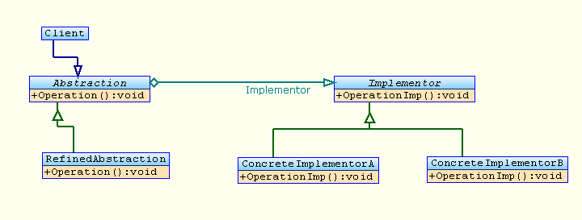
Composite
Decorator | http://en.wikipedia.org/wiki/Decorator_pattern  - To add responsibilities to individual objects dynamically without affecting other objects.  - When extension by sub classing is impractical. Sometimes a large number of independent extensions are possible and would produce an explosion of subclasses to support every combination. Or a class definition may be hidden or otherwise unavailable for sub classing.  - It is most similar to Object Chaining and Delegation.  - Eliminates the diamond problem. What if I need a subclass to talk like both frog and dinosaur – both are animals indeed.  - Mandates OCP  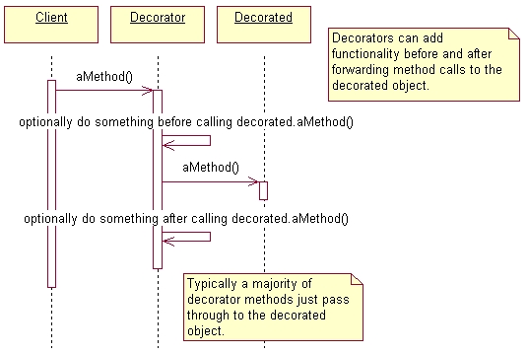  Real World Example : javax.servlet.http.HttpServletRequestWrapper – Used this in a real time application where one servlet has to do content based routing based on XPath. Servlet A converted input ServletInputStream to DOM object, did XPath , identified routing logic and delegated/forwarded it to the corresponding servlet in the ESB to process.
Façade | Use a Wrapper and give a coarse grained access instead of fine grained access. Eg: Usage in a Banking application reducing the network traffic between client and server. Don’t confuse this with decorator pattern. That is more of Object Chaining and Delegation.
Flyweight
Proxy
Behavioral
Chain of  Responsibility | grep “” <file_name> | wc -l  Handlers or Servlet filters  They promote declarative control
Command | http://en.wikipedia.org/wiki/Command_pattern
Interpreter
Iterator
Mediator
Memento
Observer | Defines a 1- n relationship between objects, so that when one object changes its state all of its dependents are notified and updated automatically.  Advantages:  - Promotes loose coupling as the only interface the subject depends is the Observer.  - Any number of Observers can come and go.  - Subject never gets changed
State
Strategy | - Relies on Composition.  - The pattern defines a family of algorithms, encapsulates each one and makes them interchangeable. Clients are relieved from varying the algorithm. The algorithm varies independently from client.  Eg: LayoutManagers in java.awt.Panel.setLayout()
Template | Demonstrates power of abstract classes VS interfaces.
Visitor

Static Factory:
Define a simple factory as a static method as we don’t need to instantiate the Factory class.
BOOM: Can’t subclass and override the behavior of the create method.

Double Checked Locking
http://www.ibm.com/developerworks/java/library/j-dcl.html
Listing 1  public static Singleton getInstance() {  if (instance == null) //1  instance = new Singleton(); //2  return instance; //3  } | Listing 2 : ThreadSafe getInstance() method  public static synchronized Singleton getInstance() {  if (instance == null) //1  instance = new Singleton(); //2  return instance; //3  }
Listing 3  public static Singleton getInstance() {  if (instance == null){  synchronized(Singleton.class) {  instance = new Singleton();  }  }  return instance;  } | Listing 4  public static Singleton getInstance() {  if (instance == null) {  synchronized(Singleton.class) { //1  if (instance == null) //2  instance = new Singleton(); //3  }  }  return instance;  }
Listing 5 : Double Checked Locking  public static Singleton getInstance() {  if (instance == null) {  synchronized(Singleton.class) { //1  Singleton inst = instance; //2  if (inst == null) {  synchronized(Singleton.class) { //3  inst = new Singleton(); //4  }  instance = inst; //5  }  }  }  return instance;  } |  | Listing 6 : JIT Optimized Double Checked Locking  public static Singleton getInstance() {  if (instance == null) {  synchronized(Singleton.class) { //1  Singleton inst = instance; //2  if (inst == null) {  synchronized(Singleton.class) { //3  //inst = new Singleton(); //4  instance = new Singleton();  }  //instance = inst; //5  }  }  }  return instance;  }
Solution
class Singleton {
private static Singleton instance = new Singleton();
private Singleton() {
}
public static Singleton getInstance() {
return instance;
}
}
public class Singleton {
// Protected constructor is sufficient to suppress unauthorized calls to the constructor
protected Singleton() {}
/**
* SingletonHolder is loaded on the first execution of Singleton.getInstance()
* or the first access to SingletonHolder.INSTANCE , not before.
*/
private static class SingletonHolder {
private final static Singleton INSTANCE = new Singleton();
}

public static Singleton getInstance() {
return SingletonHolder.INSTANCE;
}
}

Design Patterns in JDK?

Creational | Structural | Behavioral
Singleton: java.lang.Runtime | Facade : JDBC framework  Flyweight : java.lang.String uses ‘pool of constants’  Proxy : RMI Framework | Observer Observable Patterns  Strategy: LayoutManager in Swing API

Anti-Patterns
http://en.wikipedia.org/wiki/Anti-pattern

Core J2EE Design Patterns

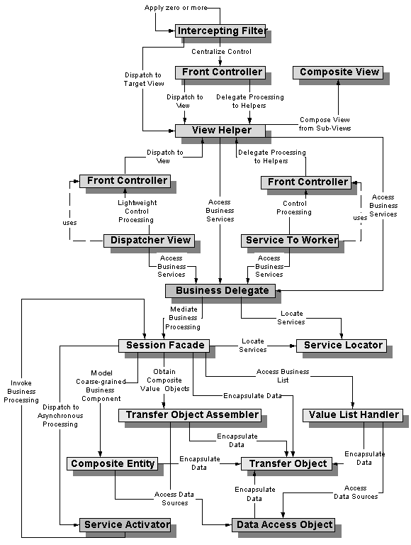

MVC
Features  - Views can change independently from controllers and models  - Mode components hide internal details(data structures) from the view and controller components  - If the model adheres to a strict contract (interface) then these components can be reused in other application areas such as GUIs or J2ME  - Separation of model code from controller code allows for easier migration to using remote business components. | Principles  - Mode, View & Controller is based on  - Separation of Concerns  - Loose Couplings  - Increases cohesion in individual components  - Increase the overall complexity of the application. This is true because even though individual components become more cohesive, MVS adds many new components to the application  - Minimized the impace of changes in other tiers of the application
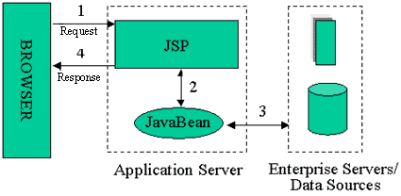 Model 1 MVC | 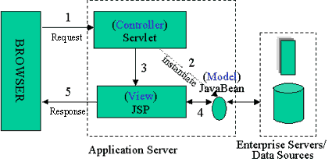 Model 2 MVC
Intercepting Filter
- Some requests to the Presentation Tier are simply forwarded to the appropriate handler component, while other requests must be modified, audited, or uncompressed before being further processed.
- The key to solving this problem in a flexible and unobtrusive manner so that they can be used in a variety of combinations (Logging and authentication, Debugging and Transformation, Uncompressing and converting encoding scheme of input) is to have a simple mechanism for adding and removing processing components, in which each component completes a specific filtering action.
Functions:  - Can intercept and/or modify requests before they reach the Servlet.  - Can intercept and/or modify responses before they are returned to the client  - Filters are deployed declaratively using the DD.  - Filters are modular so that they can be executed in chains  - Filters have lifecycles managed by the container  - Filters must implement Container callback methods | Principles  - The intercepting filter is based on  - Cohesion  - Loose Coupling  - Increasing Declarative Control  - Declarative Control allows filters to be easily implemented on either a temporary or permanent basis  - Declarative control allows the sequence of invocation to be easily updated.
Front Controller
The system requires a centralized access point for presentation-tier request handling to support the integration of system services, content retrieval, view management, and navigation. When the user accesses the view directly without going through a centralized mechanism, two problems may occur:
- Each view is required to provide its own system services, often resulting in duplicate code.
- View navigation is left to the views. This may result in commingled view content and view navigation.
- Additionally, distributed control is more difficult to maintain, since changes will often need to be made in numerous places.
A front controller centralizes functions such as view selection, security and Templating and applies them consistently across all pages or views. It delegates to helpers to complete portions of this work. Consequently, when the behavior of these functions needs to change, only a small part of the application needs to be changed: the controller and its helper classes.
Features  - Centralizes a web app’s initial request handling tasks in a single component.  - Using the front controller with other patterns can provide loose coupling by making presentation tier dispatching declarative  - A drawback of Front Controller is that it’s very barebones compared to Struts. To create a reasonable application from scratch using Front Controller pattern, you would end up rewriting many of the features already found in Struts. | Principles:  - The Front controller is based on  - Hiding Complexity  - Separation of Concerns  - Loose Coupling  - Increases cohesion in application controller components  - Decreases the overall complexity of the application  - Increases the maintainability of the infrastructure code.
Composite View
- Web Pages are built by embedding formatting code directly within each view.
- Multiple composite views use similar subviews. These atomic portions are decorated with different surrounding template text, or they appear in a different location within the page. (like a search button subview).
- Modification to the layout of multiple views is difficult and error prone, due to the duplication of code.
- Atomic portions (sub views) of view content change frequently.
- Layout changes are more difficult to manage and code harder to maintain when subviews are directly embedded and duplicated in multiple views.
- Embedding frequently changing portions of template text directly into views also potentially affects the availability and administration of the system. The server may need to be restarted before clients see the modifications or updates to these template components.
- Composite View is based on the inclusion and substitution of modular dynamic and static template fragments. It promotes the reuse of atomic portions of the view by encouraging modular design. It is appropriate to use a composite view to generate pages containing display components that may be combined in a variety of ways. This scenario occurs, for example, with portal sites that include numerous independent subviews, such as news feeds, weather information, and stock quotes on a single page. The layout of the page is managed and modified independent of the subview content.
- Another benefit of this pattern is that Web designers can prototype the layout of a site, plugging static content into each of the template regions. As site development progresses, the actual content is substituted for these placeholders.
<jsp:include>
Use a View Manager which invokes multiple RequestDispatcher.include() calls to header and footer components.
Differs from View Helper as the Composite View decides which sub-views to include while View Helper generally decides how to display a given sub-view.
View Helper
View
- A view represents and displays information to the client. The information that is used in a dynamic display is retrieved from a model. Helpers support views by encapsulating and adapting a model for use in a display.
Helper
- A helper is responsible for helping a view or controller complete its processing. Thus, helpers have numerous responsibilities, including gathering data required by the view and storing this intermediate model, in which case the helper is sometimes referred to as a value bean. Additionally, helpers may adapt this data model for use by the view. Helpers can service requests for data from the view by simply providing access to the raw data or by formatting the data as Web content.
A view may work with any number of helpers, which are typically implemented as JavaBeans (JSP 1.0+) and custom tags (JSP 1.1+). Additionally, a helper may represent a Command object, a delegate, or an XSL Transformer, which is used in combination with a stylesheet to adapt and convert the model into the appropriate form.
Value Bean
A value bean is another name for a helper that is responsible for holding intermediate model state for use by a view. Sometimes a ValueBean fulfills the role of a Transfer Object.
Dispatcher View
- Dispatcher View - is a macro pattern describes the combination of the Front Controller and View Helper patterns with a dispatcher component.
- It controls access to presentation processing (using Front Controller), manages and controls flow of execution(Using Dispatcher Component) and uses View Helpers responsible for generating dynamic content.
- While this pattern and the Service to Worker pattern describe a similar structure, the two patterns suggest a different division of labor among the components.
- The controller and the dispatcher typically have limited responsibilities, as compared to the Service to Worker pattern, since the upfront processing and view management logic are basic.
- In the Service to Worker pattern, the dispatcher typically plays a moderate to large role in view management.
  - Limited Role: By limited it means that the dispatcher doesn’t utilize other outside resources in order to choose the view. The information in the request is sufficient to determine the view to dispatch the request. For example: http://some.server.com/servlet/Controller?next=login.jsp. The sole responsibility of the dispatcher component in this case is to dispatch to the view login.jsp
  - Moderate Role: An example of the dispatcher playing a moderate role is the case where the client submits a request directly to a controller with a query parameter that describes an action to be completed: http://some.server.com/servlet/Controller?action=login
The responsibility of the dispatcher component here is to translate the logical name login into the resource name of an appropriate view, such as login.jsp, and dispatch to that view. To accomplish this translation, the dispatcher may access resources such as an XML configuration file (struts-config.xml)that specifies the appropriate view to display.
- Sophisticated Role: On the other hand, in the Service to Worker pattern, the dispatcher might be more sophisticated. The dispatcher may invoke a business service to determine the appropriate view to display.
Service To Worker
Macro Pattern
Refer Dispatcher View
Business Delegate
- Provides access to business services
Business Service
The business service is a role that is fulfilled by the service the client is seeking to access. Typically, the business service is accessed via a Business delegate. The business delegate's role is to provide control and protection for the business service.
Features  1. Acts as a proxy, implementing the remote services’ interface  2. Initiates communications with a remote service  3. Handles communication details and exceptions  4. Receives request from controller component  5. Translates the request and forwards it to the business service using a stub.  6. Translates the response and returns it to the controller component.  7. By handling details of remote component lookup and communications, allows controllers to be more cohesive |  | Advantages & Principles  - Based on  - Hide Complexity  - Coding to Interface  - Loose Coupling  - Separation of Concerns leading to Cohesion  - Minimize impact on web tier when changes happen in business tier.  - Reduce coupling between tiers.  - Adds a layer to the application, which increases complexity.  - Coarse Grained calls to reduce network traffic.
Service Locator
Features:  - Obtain initialContext Objects  - Performs registry lookups  - Handles communication details and exceptions  - Can improve performance by caching previously obtained references  - Works with a variety of registries such as JNDI, RMI, UDDI and COS naming |  | Principles:  - Based on  - Hide Complexity  - Separation of Concerns leading to Cohesion  - Minimize impact on web tier when remote components change locations or containers.  - Reduce coupling between tiers.
Session Façade
Mediate Business Processing in a workflow
- Coordinate operations between multiple business objects in a workflow
- The Session Facade pattern defines a higher-level business component (Session Bean) that contains and centralizes complex interactions between lower-level business components.
- A Session Facade is implemented as a session enterprise bean. It provides clients with a single interface for the functionality of an application or application subset. It also decouples lower-level business components from one another, making designs more flexible and comprehensible.
Transfer Object
Features:  - Provides a local representation of a remote entity (i.e., an object that maintains some data state)  - Minimize network traffic  - Can follow Java Bean conventions so that is can be easily accessed by other objects  - Implemented as a serializable object so that it can move across the network  - Typically easily accessible by view components | Principles:  - The transfer object is based on  - reducing network traffic  - Minimizes the performance impact on the web tier when remote components data is accessed with fine-grained calls  - Reducing coupling between tiers  - A drawback is that components accessing the Transfer object can receive out-of-date data because the transfer object's data is really representing state that is stored somewhere else  - Making updatable Transfer Objects Concurrency-sage is typically complex.
Data Access Object
Abstract and encapsulates data access mechanisms
- Code that depends on specific features of data resources ties together business logic with data access logic or persistence logic. This makes it difficult to replace or modify an application's data resources.
- The Data Access Object (or DAO) pattern:
  - separates a data resource's client interface from its data access mechanisms
  - adapts a specific data resource's access API to a generic client interface
The DAO pattern allows data access mechanisms to change independently of the code that uses the data.
+ Leverages a proven solution + Provides a common vocabulary + Constrains solution space
Good Resources:
[1] http://www.theserverside.com/books/wiley/EJBDesignPatterns/index.tss [good book]
[2] http://java.sun.com/blueprints/corej2eepatterns/Patterns/ [the book is available online]
[3] http://www.dofactory.com/Patterns/Patterns.aspx [GoF patterns]
[4] http://www.patterndepot.com/put/8/JavaPatterns.htm [pdf book with java code]
[5] Head First Design Patterns.

Algorithm

Data Structures

Stacks

Queues

Trees

Graphs

Heaps
A heap is a specialized tree-based data structure that satisfies the heap property: if B is a child node of A, then key(A) ≥ key(B).
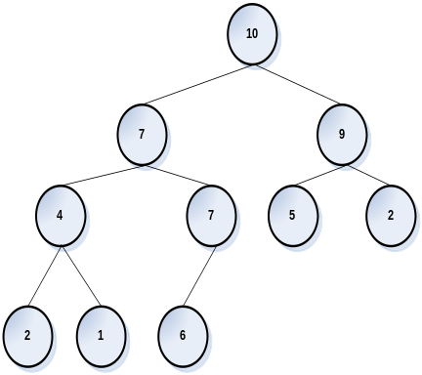 | 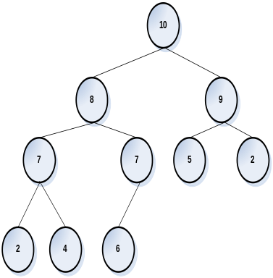  Suppose 1 is modified to 8.  After percolating 8 to its place. | 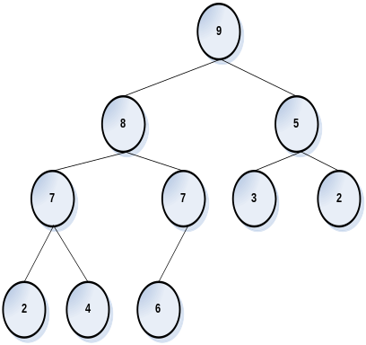  Suppose 10 is modified to 3.  After sifting 3 down to its place.

Order of Algorithms
How to improve from O(n²) to O(n) to O(log n)

Permutations

String Algorithms
Reverse a String
Find repeating characters
Find Non Repeating characters
Find Blank spaces
Strip blank spaces
Remove duplicates and count

Sorting Algorithms
Bubble Sort

O( n log n )
program | recurrence | solution
Program | T(n)=T(n/2)+O(1)
Program | T(n)=2T(n/2)+O(1) | O(n)
Program | T(n)=2T(n/2)+O(n)
Table: Running times of divide-and-conquer algorithms.

Heap Sort
Merge Sort
Quick Sort

Search Algorithms

Arrays
Shuffle a deck

Stacks and Queues

List
Lists Union Ascending
Lists Union Descending
Lists Intersection
Lists Repeating

Trees

Graph

I have a class SalesOrder which has a method calculating salesOrder_US(). Now If I want to grow how can I implement for other countries without affecting this class.

Hashing
Hashing
Collision
Chaining
Open Addressing

Random Number

UML

Symbols
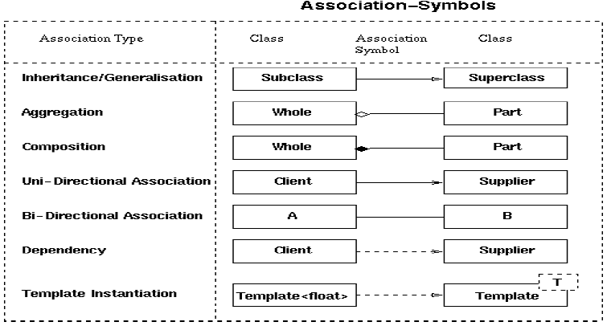

Association
Association represents the ability of one instance to send a message to another instance. This is typically implemented with a pointer or reference instance variable, although it might also be implemented as a method argument, or the creation of a local variable.
[Example:]
|A|----------->|B|

class A
{
private:
B* itsB;
};

Aggregation
Aggregation is the typical whole/part relationship. This is exactly the same as an association with the exception that instances cannot have cyclic aggregation relationships (i.e. a part cannot contain its whole).
[Example:]
|Node|<>-------->|Node|

class Node
{
private:
vector<Node*> itsNodes;
};

The fact that this is aggregation means that the instances of Node cannot form a cycle. Thus, this is a Tree of Nodes not a graph of Nodes.

Composition
Composition is exactly like Aggregation except that the lifetime of the 'part' is controlled by the 'whole'. This control may be direct or transitive. That is, the 'whole' may take direct responsibility for creating or destroying the 'part', or it may accept an already created part, and later pass it on to some other whole that assumes responsibility for it.
[Example:]
|Car|<#>-------->|Carburetor|

class Car
{
public:
virtual ~Car() {delete itsCarb;}
private:
Carburetor* itsCarb
};

Web Services and SOA

Web Services

What is XML-RPC based WS
XML-RPC was developed in Microsoft during 1998. It defined the commonly used data types in XML like
<i4>42</i4>
<int>42</int>
For integer datatypes. As more functionalities were introduced it evolved itself into SOAP.
http://en.wikipedia.org/wiki/XML-RPC
It defined request and response messages. Responses included special element for faults.

What is RPC based WS?

What is XML based WS?

Difference between “SOAP 1.1” and “1.2”?
https://www.sdn.sap.com/irj/servlet/prt/portal/prtroot/docs/library/uuid/74bae690-0201-0010-71a5-9da49f4a53e2#

When to use Document VS RPC style?

http://www.xml.com/pub/a/ws/2004/05/26/binding.html
The nice thing about document/literal is that it forces the actual payload of a SOAP message to be defined entirely using W3C XML Schema, independent of SOAP and WSDL. The child of the soap:Body element can stand alone as its own XML document.
This is the kind of encapsulation that should make a design patterns aficionado go weak at the knees. Not only could the SOAP body's contents readily be validated against a schema, but if the web services platform leverages a schema binding framework with a public API, the same schema can be used to serialize XML not just to a SOAP message but to any destination: a file, as a node within a larger document, whatever.
http://www.ibm.com/developerworks/webservices/library/ws-docstyle.html

Style | Advantages
Document | - Eases Validation  - Contract is Rigid – If a method changes no need to change WSDL.  - Promotes Async Processing  - Use for Stateful services for maintaining states  - Use outside enterprise boundaries  - Use for easy validation  - Use when RPC Marshalling consumes more mem when compared to DOM and SAX APIs
RPC

Style |  | Advantages | Disadvantages
RPC | Encoded | - SOAP body comes with a <myMethod> element = operationName which comes from WSDL  - Definitions - Makes client easy to identify which method to invoke | - SOAP body comes with a <myMethod> element  - Not easy to validate.  - Encoding info degrades performance.
RPC | Literal | WS-I Compliant  Good for method Overloading | <myMethod> comes from WSDL Definitions
Document | Encoded
Document | Literal | Easy Validation  Operation name comes  WS-I Compliant | Complicated WSDL  No operation Name  WS-I allows only one child
Document | Literal Wrapped

What is the need for UDDI?
Universal Description, Discovery and Integration (UDDI)

J2EE VS SOA?
Scalability for J2EE is different than for EAI, which is a P2P model.

Explain WS-Addressing and what it offers
http://www.infoq.com/articles/sanjiva-rest-myths

What is REST?
http://www.infoq.com/articles/rest-introduction
http://cafe.elharo.com/web/why-rest-failed/
http://www.artima.com/lejava/articles/why_put_and_delete.html

When to use SOAP vs REST?
From Integration perspective REST talks only about Point to Point Integration, where as WS-* talks a transport agnostic way of Integration and service composition.
http://www.oracle.com/technetwork/articles/javase/index-137171.html
Use Rest, when:
- The web services are completely stateless. A good test is to consider whether the interaction can survive a restart of the server.
- A caching infrastructure can be leveraged for performance. If the data that the web service returns is not dynamically generated and can be cached, then the caching infrastructure that web servers and other intermediaries inherently provide can be leveraged to improve performance. However, the developer must take care because such caches are limited to the HTTP GET method for most servers.
- The service producer and service consumer have a mutual understanding of the context and content being passed along. Because there is no formal way to describe the web services interface, both parties must agree out of band on the schemas that describe the data being exchanged and on ways to process it meaningfully. In the real world, most commercial applications that expose services as RESTful implementations also distribute so-called value-added toolkits that describe the interfaces to developers in popular programming languages. – This was until WSDL 1.1 from 2.0 the WSDL HTTP Binding can describe restful webservices too.
http://www.ibm.com/developerworks/webservices/library/ws-restwsdl/
- Bandwidth is particularly important and needs to be limited. REST is particularly useful for limited-profile devices such as PDAs and mobile phones, for which the overhead of headers and additional layers of SOAP elements on the XML payload must be restricted.
- Web service delivery or aggregation into existing web sites can be enabled easily with a RESTful style. Developers can use technologies such as Asynchronous JavaScript with XML (AJAX) and toolkits such as Direct Web Remoting (DWR) to consume the services in their web applications. Rather than starting from scratch, services can be exposed with XML and consumed by HTML pages without significantly refactoring the existing web site architecture. Existing developers will be more productive because they are adding to something they are already familiar with, rather than having to start from scratch with new technology.
Use SOAP, when:
- A formal contract must be established to describe the interface that the web service offers. The Web Services Description Language (WSDL) describes the details such as messages, operations, bindings, and location of the web service.
- The architecture must address complex nonfunctional requirements. Many web services specifications address such requirements and establish a common vocabulary for them. Examples include Transactions, Security, Addressing, Trust, Coordination, and so on. Most real-world applications go beyond simple CRUD operations and require contextual information and conversational state to be maintained. With the RESTful approach, developers must build this plumbing into the application layer themselves.
- The architecture needs to handle asynchronous processing and invocation. In such cases, the infrastructure provided by standards such as WSRM and APIs such as JAX-WS with their client-side asynchronous invocation support can be leveraged out of the box.

XML

What is the need for a Schema?
Though Schema is good, it does only syntactic validation. It doesn’t do semantic validation.

How DTD does differ from a Schema?
http://www-128.ibm.com/developerworks/xml/library/x-matters7.html

Features | DTD | XML Schema
Rich Typing | Either #CDATA or #PCDATA | Built in data types  Allows building new dataypes.
Occurrence Constraints | Contains only ? * +  Have to repeat the data for ranges n-m | minoccurs and maxoccurs
Enumeration | Only attributes | Both attributes and elements using simpleType. This allows the enum to be used anywhere unlike DTD.

PCDATA vs CDATA
PCDATA means parsed character data. Think of character data as the text found between the start tag and the end tag of an XML element. PCDATA is text that WILL be parsed by a parser. The text will be examined by the parser for entities and markup.
Tags inside the text will be treated as markup and entities will be expanded.
However, parsed character data should not contain any &, <, or > characters; these need to be represented by the &amp; &lt; and &gt; entities, respectively.
CDATA means character data. CDATA is text that will NOT be parsed by a parser. Tags inside the text will NOT be treated as markup and entities will not be expanded.

What is the need for a namespace in XML Schema?
The XML namespaces recommendation defines a way to distinguish between duplicate element type and attribute names. http://www.rpbourret.com/xml/NamespacesFAQ.htm

Xpath vs Xquery
XQuery is similar to SQL and provides JOINS between multiple documents with where clause and stuffs.

Testing

Thoughts on Test Driven Development?
http://en.wikipedia.org/wiki/Test-driven_development
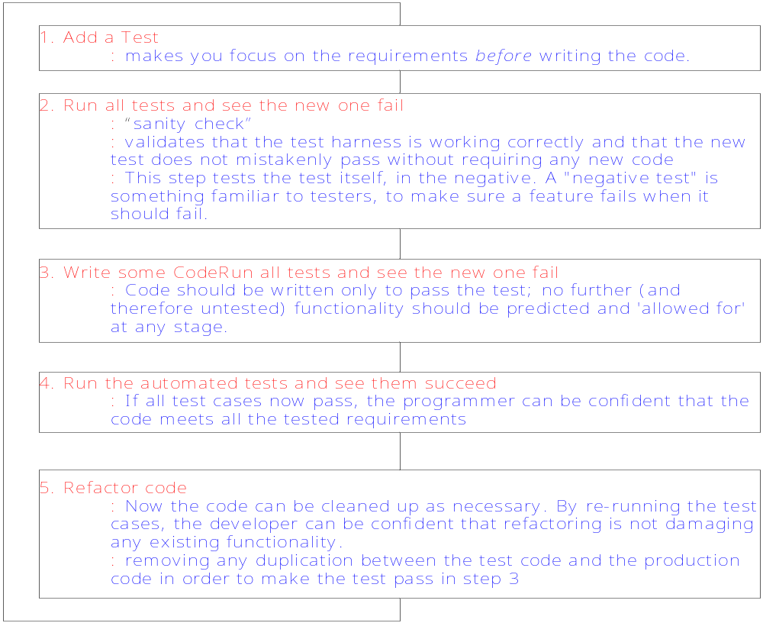

Benefits
- “Test-Driven Development Mantra”, known as red/green/refactor
- Makes one to concentrate on the Interface [ Design by Contract]
- Code Coverage
- Write tests to achieve a design pattern

Unit Testing?
Testing a class in isolation

Load Testing?
TODO-TODO-TODO-TODO-TODO

Functional Testing?
TODO-TODO-TODO-TODO-TODO

Performance and Profiling

Detecting Memory Leaks in Java?
  - OutOfMemoryError indicates memory leak - Obvious
  - Runtime.getRuntime().totalMemory() – Runtime.getRuntime().freeMemory()
  - Use operating system process monitors
  - Use Profiling tools

Improving performance at code level and as a programming practice
ftp://ftp.glenmccl.com/pub/free/jperf.pdf
Classes:
  - Try to provide empty constructors. Cost of JRE creating default constructors for a class hierarchy and invoking them is much more.
  - Use static variables when needed(esp. Arrays) in place of using instance variable. Eg: If a class ABC is in need of a array initialized with values in String[] str = {“a”,”b”,”c”}, instantiating ABC 100 times in a for loop will create 100 str object. If the same is defined as static, it will get instantiated only once.
Methods:
  - Method Inlining – Inline methods when possible for smaller functions like finding max or min to avoid call to method stacks.
  - Making methods final.
public final void function(){…}
public <final> class A {..}
A aref = new A();
aref.function();
The above is like calling A’s method function(), and not some function() in a subclass of A if A is made final.
String:
  - User StringBuffer where possible
  - User char[] or byte[] when you know the length of the String that you will be creating in ahead.
  - Use == || str1.equals(str2) short circuit operations during equals check. ➔ Always perform cheap performance test before performing expensive test
  - String Interning
public class StringInterning{
public static void main(String[] pArgs) {
String str = new String(“testing”);
if ( str == “testing” )
System.out.println(“equal”);
else
System.out.println(“unequal”);
str = str.intern();
if ( str == “testing” )
System.out.println(“equal”);
else
System.out.println(“unequal”);
}
}
  - Never invoke String.length() method in a for loop for computing the loop index.
  - Use toCharArray and iterate over the array instead of using chatAt() method.
  - new Double(“12.34”) is expensive than new Double(12.34)
Input/Output:
  - Buffering – Always use buffering while doing I/O operations
  - String formatting – Using java.text.MessageFormat based templates to format strings (these templates are precomiled) is expensive than printing strings as such.
  - Avoid calling File.length() redundantly in a program unless you suspect any file changes while processing.
Libraries:
  - System.arraycopy() performs better than Object.clone() which performs better than looping through the array and copying items.
  - Vector vs ArrayList
    - Vector’s methods are synchronized, ArrayListS are not. This means that Vector is threadsafe, at some extra cost.
    - The collection framework provides an alternative to ArrayList called LinkedList , which offers different performance tradeoffs.
    - When Vector needs to grow its internal data structure to hold more elements, the size of the structure is doubled, whereas for ArrayList, the size is increased by 50%. So ArrayList is more conservative in its use of space.
    - It’s worth using the collection framework in your applications if you possibly can, because it’s now the "standard" way to handle collections. If you are concerned about thread safety, one way to handle this issue is to use wrappers around objects like ArrayList , for example: List list = Collections.synchronizedList(new ArrayList());
  - ArrayList.ensureCapacity() → setting this to a predefined value stops ArrayList to grow dynamically every time during an ArrayList.add()operation
  - ArrayList vs LinkedList – Adding elements in ArrayList is expensive compared to LinkedList. Whereas Retrieving elements from an ArrayList is very cheap when compared to LinkedList.
  - Programming to interface like List or Map improves efficiency of your application.
Size:
  - .class file size
javac Code, SourceFile, LineNumberTable
javac –g Code, SourceFile, LineNumberTable, LocalVariableTable
javac -g:none Code
If you strip out information such as line numbers from .class files, you may have problems with debugging and exception reporting.
  - Using Wrapper variables a lot in place of primitive types as instance variables will increase the size of your bytecode.
  - Clear references of large unused objects by explicitly setting their references to null
  - Use SoftReference when possible for caching mechanisms
  - Use BitSet when you want to store Boolean arrays.
  - Sparse Arrays

GC Tuning
http://www.petefreitag.com/articles/gctuning/
Garbage collection normally consumes from 5% to 20% of total execution time of a properly functioning application. The initial heap size is a threshold that triggers new garbage collection cycles. If the initial heap size is 10 MB, for example, then a new collection cycle is triggered as soon as the JVM detects that 10 MB have been allocated since the last collection cycle. Smaller heap sizes result in more frequent garbage collections than larger heap sizes.

JMeter experience?

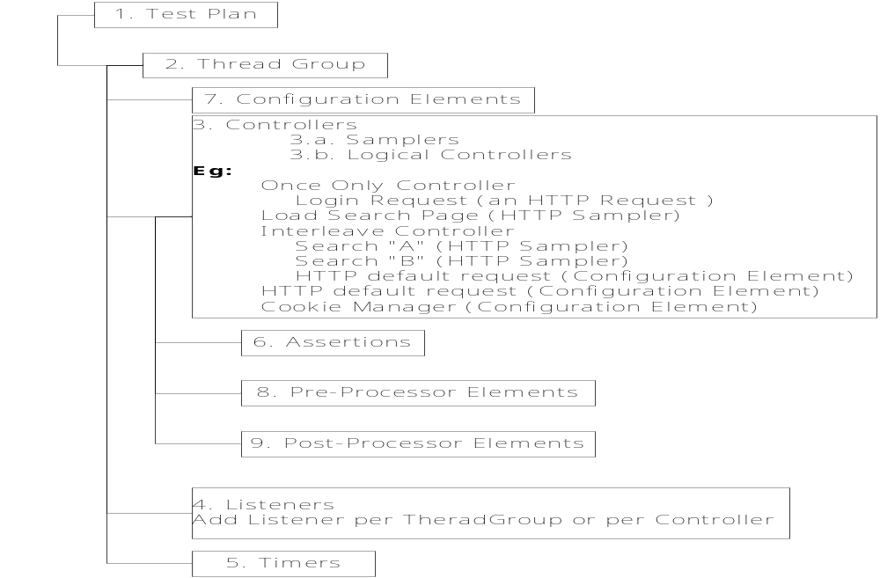
Distributed Testing: Multiple JMeters can be configured to test a web server

Monitoring and Management in JDK
http://java.sun.com/developer/technicalArticles/J2SE/monitoring/
Problems | Description |  | Tools
Insufficient Memory | Heap  Memory Error | java.lang.OutOfMemoryError: Java heap space | jconsole
Insufficient Memory | Non-heap Memory Error | java.lang.OutOfMemoryError: PermGen space | jconsole
Insufficient Memory | Native  Memory Error | java.lang.OutOfMemoryError: request <size> bytes for <reason>.  Out of swap space? | jconsole
Memory Leaks | Unintentional object retention |  | jconsole  jstat  jmap  jinfo  jhat
finalizerS | An object that has a finalizer will not be garbage collected until its finalizer is run. Thus, objects that are pending for finalization will retain memory even though the objects are no longer referenced by the application, and this could lead to a problem similar to a memory leak. |  | jconsole  jmap
Deadlocks |  |  | jconsole  jstack
Looping Threads | When loop = Infinity |  | jtop + jconsole
High Lock Contention

JVM Monitoring Tools
jconsole | - Memory usage and garbage collection activities  - Thread state, thread stack trace, and locks  - Number of objects pending for finalization  - Runtime information such as uptime and the CPU time that the process consumes  - VM information such as the input arguments to the JVM and the application class path
jstat | command to monitor the memory usage and garbage collection statistics
jmap | When you suspect a memory leak in an application, the command will help you get a heap histogram that shows the per-class statistics, including the total number of instances and the total number of bytes occupied by the instances of each class.
jmap | Tips  - Its instances occupy unexpectedly large amounts of memory.  - The number of instances of the class is growing over time at a high rate.  - Class instances that you would expect to be garbage collected are not.
jmap | -histo  -dump  -finalizerinfo
jinfo | jinfo -flag +HeapDumpOnOutMemoryError <pid>  java -XX:+HeapDumpOnOutOfMemoryError
jhat | Analyzes the heap dump and starts a HTTP Server on port 7000 with Query interface

Solaris Monitoring Tools
prstat
sar 2 100 (run sar for 100 times every 2 secs)

Non-Functional Aspects

Fail-over VS Fault-tolerant?
HA | High availability refers to systems with redundant components that provide consistent, uninterrupted service, even during failures. In most high availability configurations, nodes are isolated from each other so that a failure on one node does not affect the entire system.  There are two factors that determine system availability:  1. The first factor is the reliability of the individual components that comprise the system. These components include server hardware, server operating system and the application itself. Other components may include data storage devices, network access devices, databases, file systems and the data center infrastructure.  2. The second factor is the time it takes for the application to be restored once a failure has occurred. The amount of time it takes to bring an application online again is dependent on the component that failed. If the application itself has failed, all that may be required for recovery is to simply restart the application.  High availability must encompass all components required to provide a service. Certain components of a service may be highly available, however, other system components may not support the same level of high availability, therefore, overall availability is reduced.
FT | Now that we have a clear understanding of high availability, we can contrast this concept with fault tolerance. Fault tolerance differs from high availability by providing additional resources that allow an application to continue functioning after a component failure without interruption. Many of the high-availability solutions on the market today actually provide fault tolerance for a particular application component. Disk mirroring, where there are two disk drives with identical copies of the data, is an example of a fault-tolerant component. If one of the disk drives fail, there is another copy of the data that is instantly available so the application can continue execution.  A fully fault-tolerant solution requires that all the resources the application is dependent on, be replicated including the application process itself. This requires an independent processor (not part of the same computer) and a copy of the memory that the application uses. In the worst case failure scenario, one in which the processor or memory fails, the replicated version of the application continues to execute. Other failures simply require the application to use the alternate resources (disks, communications devices). As a result of this complete hardware and process replication, fault-tolerant systems are significantly more expensive than highly available systems.
Failover | Failover is a backup operational mode in which the functions of a system component (such as a processor, server, network, or database, for example) are assumed by secondary system components when the primary component becomes unavailable through either failure or scheduled down time. Used to make systems more fault-tolerant, failover is typically an integral part of mission-critical systems that must be constantly available.
LB

Fault tolerance
Simply defined, fault tolerance is the ability of a compute system to provide uninterrupted compute functions with no loss of process or data. In more complete terms, fault tolerance is the ability of two or more compute nodes to provide uninterrupted and expected services despite faults that occur internally or externally to the control of a system or application. Faults that occur internally to the control of a system might be compute node component failures (e.g., memory, CPU), disk drive errors, or operating system/application crashes. Faults that occur externally to the control of a system might be the building-wide loss of electricity, the physical severing of network connections, or the destruction of the system or data center by fire or natural disaster. While the external faults are typically aggregated and defined within the context of disaster recovery, a fault-tolerant environment must comprehend and, to some degree, support the requirements of disaster recovery.

Miscellaneous

AOP
http://www-128.ibm.com/developerworks/rational/library/2782.html

URN, URI and URL
http://en.wikipedia.org/wiki/Uniform_Resource_Identifier
http://www.bernzilla.com/item.php?id=100
- A URI is a standard global identifier for an Internet resource that may be local or remotely-accessible. URIs follow the same general syntax as URLs; in fact, URLs are one type of URI.
- Whereas URLs always refer to network addresses (including a protocol specification, host name or address, and local path), a URI does not necessarily refer to a remote resource. For example, the URI file:///c:/ specifies a local directory. Because file does not refer to any specific network protocol, this URI is not also a URL.

WorkManager API advantages?

Timer API advantages?
- Ease of use in terms of Dependency Injection
- Since the responsibility of task execution would be left to the API and would remove the requirement to maintain this logic in more than one place.
- When inside these managed environments, this API is a much better alternative to java.util.Timer: java.util.Timer should never be used within managed environments, as it creates threads outside the purview of the container. Further, there is no clean way of sub classing java.util.Timer to avoid thread creation, as all constructors create and start a thread. This API is also a better choice than using the JMX Timer Service because the JMX Timer Service API is tightly coupled with the JMX framework and thus does not provide a sufficiently user-friendly or independent API.
- When inside managed environments, Work Manager API is a much better alternative to java.lang.Thread, as Thread should never be used by application-level code within managed environments as the container needs full visibility and control over all executing threads. Also, this Work Manager API is a better alternative than the J2EE Connector Architecture 1.5 Work Service, as the JCA Work Service is tightly coupled with the JCA framework and thus does not provide a sufficiently independent API for use outside JCA. In particular, the JCA javax.resource.spi.work.WorkManager interface exposes methods taking javax.resource.spi.work.ExecutionContext, which is not generally the context mechanism that should be used by J2EE applications.

The Timer and Work Manager for Application Servers specification thus provides a clean, simple, and independent API that is appropriate for use within any J2EE container.

Comment Ruby, Python

Bad things in Java
- Uniform abstractions (everything is an object, no primitives).
- Full polymorphism through message sending
- Full closures
- Continuations
- Immediacy of development
- Classes as first class objects
- Meta-programming
- Functional programming
- 80% of the expressiveness of Lisp style macros
- Higher order functions
- Internal DSL's
- Editing code whilst it's still running.
- Object Memory
- Object specific classes
- Mixins

Transformation vs. Translation
http://msdn.microsoft.com/en-us/library/ms916577.aspx
Mapping data relies on two basic operations: Data transformation and Data translation.
Data transformation is the process of creating a correspondence between records and fields of a source schema to (often different) records and fields in a destination schema. An example of data transformation is to map shipping and billing address information from a purchase order to an invoice. This is the most basic type of mapping. Data transformation can also apply to operations such as:
- Averaging data from a looping record and sending the output to a single field in the destination schema.
- Converting character data to its ASCII format.
- Adding or subtracting data from one or more records and putting the result in a single field in the destination schema.
Data translation is the process of changing the format of an instance message. Data translation is very helpful in solving enterprise application integration problems by translating a given type of message into alternative formats required by existing systems.

Front Controller pattern defines a single component that is responsible for processing application requests. The struts ActionServlet is an example of Front Controller pattern. Struts use Model 2 architecture of MVC pattern. Every request that comes to the controller servlet is delegated to Action classes which then invoke java beans in the model to perform business logic. Then the response generated is sent to the VIEW part which is a JSP or HTML. A front controller centralizes functions such as view selection, security and Templating and applies them consistently across all pages or views. It delegates to helpers to complete portions of this work. Consequently, when the behavior of these functions needs to change, only a small part of the application needs to be changed: the controller and its helper classes.
- Need for Centralize application request processing: Many interactive Web applications are composed of brittle collections of interdependent Web pages. Such applications can be hard to maintain and extend.
Model 1 MVC | Model 2 MVC
View Helper
- A View Helper is a class that does data retrieval for the view. It adapts a data resource to a simple API usable by application views. Thus they normally hold data from the value object and are called as Value beans.
- Using helper’s results in a cleaner separation of the view from the business processing in an application, since business logic is factored out of the view and into the helper component. We can use a JavaBean, which aids in content retrieval and adapts and stores the model for use by the view.
- Basically anything that helps you display your model data in a reusable fashion.
- Implemented as JavaBeans, jsp actions custom tags or xml/xslt.
- Currently using jsp actions, JavaBeans and xslt as we work on building our standard tag library.
Dispatcher View
Dispatcher View combines the Front Controller and View Helper patterns with a dispatcher component. It is structurally similar to Service to Worker pattern. But they both describe different division of labor among the components. In Dispatcher View pattern the controller and the dispatcher typically have limited responsibilities, as compared to the Service to Worker pattern.
- Unlike the Service to Worker pattern, the Dispatcher View pattern suggests deferring content retrieval to the time of view processing.
The dispatcher typically plays a limited to moderate role in view management.
In the Service to Worker pattern, the dispatcher typically plays a moderate to large role in view management.
Limited Role: By limited it means that the dispatcher doesn’t utilize other outside resources in order to choose the view. The information in the request is sufficient to determine the view to dispatch the request. For example: http://some.server.com/servlet/Controller?next=login.jsp. The sole responsibility of the dispatcher component in this case is to dispatch to the view login.jsp
Moderate Role: An example of the dispatcher playing a moderate role is the case where the client submits a request directly to a controller with a query parameter that describes an action to be completed: http://some.server.com/servlet/Controller?action=login
The responsibility of the dispatcher component here is to translate the logical name login into the resource name of an appropriate view, such as login.jsp, and dispatch to that view. To accomplish this translation, the dispatcher may access resources such as an XML configuration file that specifies the appropriate view to display.
Sophisticated Role: On the other hand, in the Service to Worker pattern, the dispatcher might be more sophisticated. The dispatcher may invoke a business service to determine the appropriate view to display.

The dispatcher uses the RequestDispatcher object (supported in the servlet specification), but it also typically encapsulates some additional processing. The more responsibilities that this component encapsulates, the more it fits into the Service to Worker pattern.
Service To Worker
In the Dispatcher view, the front controller has less work to do - it allows the view to retrieve content. In the Service To Worker pattern, the front controller has more responsibility. It must retrieve the content itself and use it to populate "something" (e.g. JavaBeans) that the view can later use. Struts implements the Service to Worker pattern, a developer can use an XML file to map request parameters to actions and the results of actions to other actions or to result pages. The anti-pattern alternative is to have each servlet or JSP directly specify the next servlet or JSP and for that next servlet or JSP to provide the business logic action as prelude to rendering the next view. That would create the tight view-controller coupling that the Front Controller and Service to Worker were designed to avoid.
For example, we are using the struts framework which has a front controller (ActionServlet) which uses configured Action classes (helpers) to retrieve content. The servlet then dispatches the configured view (normally jsp, but we are using xsp/xsl).
Disadvantages: In a Service-to-Worker pattern, the Controller is more responsible for processing the form data from JSP's, has a performance overhead since all requests come to the controller first. The benefits to a Dispatcher-View pattern, in which the final JSP is responsible for populating its own view, is that when the Controller forwards the request, the server executes the resulting JSP in a separate virtual port. This, he says, is advantageous since the processing from that point on is done by a single thread.
All the above 5 [Front Controller, MVC, View Helper, Dispatcher View, Service to Worker] patterns are used in Struts
Business Delegate – While designing an EJB application, the system use cases should be divided up over a layer of session beans using the façade pattern for coarse grained access by the client. And to interact with this layer the client code makes a directly invocation. Like to access a session bean presentation layer has to directly interact with EJBHomes and EJBObjects for Sesssion beans and send JMS messages when they want to talk with message-driven beans. To avoid this we create a layer of business delegates, which are plain java classes capable of hiding the EJB API complexity. A Business Delegate encapsulates the code which locates delegates and recovers from invocations on the session façade EJB layer.
Advantages
- Reduces separation of roles between client side programmers and server programmers.
- Places optimistic concurrency recovery responsibility on clients. – In some applications it may not be necessary to propagate the transaction exceptions to the user and ask him to retry the application.
- Reduces the client logic from complex exception handling.
Design Issues:
- Must be serializable:
As they are stored in a servlet session they must be declared as Serializable to support servlet engines which passivate HTTPSessions or supporting session replication in clusters.
Must use an EJB Handle to support serialization: Since EJBObjects are not guaranteed to be serializable the delegate must be written to use a handle object so that the reference to the stateful session bean will remain intact even through serialization.
Service Locator -- Simplify client access to enterprise business services
- Enterprise applications require a way to look up the service objects that provide access to distributed components. JavaTM 2 Platform, Enterprise Edition (J2EE) applications use Java Naming and Directory Interface (JNDI) to look up enterprise bean home interfaces, Java Message Service (JMS) components, data sources, connections, and connection factories. Repetitious lookup code makes code difficult to read and maintain. Furthermore, unnecessary JNDI initial context creation and service object lookups can cause performance problems.
- The Service Locator pattern centralizes distributed service object lookups, provides a centralized point of control, and may act as a cache that eliminates redundant lookups. It also encapsulates any vendor-specific features of the lookup process.
Session Façade –- Often in an enterprise application a client has to perform business logic which involves fine-grained invocation of [accessing and modifying] multiple server-side objects like multiple entity and session beans. This involves lot of network overhead with multiple transaction calls. Also the workflow/business logic gets scattered across clients. So we need a server side abstraction that wraps the entity bean layer by introducing another layer of session beans through which the client performs coarse grained access. So the client has access to a session bean and not to entity beans.
Design Issues:
- God-Class Problem: Often developers put all the use cases to one session bean.
- Placing domain logic in session beans:
- Duplication of business logic across the façade: like creditCardVerify()
Advantages:
- Low network overhead
- Clean and strict separation of business logic from presentation layer.
- Transactional Integrity: In this case acts as a Transactional façade where transactions are demarcated at session bean method level.
- Fewer changes needed in Client side code when we change the business logic.
- Helps in development of the tool. Reduces the overlap of developers of presentation layer and business layer. [For better explanation with diagram refer EJBDesign Patterns book]
Data Access Object (DAO) -- Abstract and encapsulates data access mechanisms
- Code that depends on specific features of data resources ties together business logic with data access logic or persistence logic. This makes it difficult to replace or modify an application's data resources.
- The Data Access Object (or DAO) pattern:
  - separates a data resource's client interface from its data access mechanisms
  - adapts a specific data resource's access API to a generic client interface
- The DAO pattern allows data access mechanisms to change independently of the code that uses the data.
Transfer Object [Previously known as Value Object]
Client tier in an EJB system transfers/ exchanges bulk data with the server. This particularly happens in scenarios where some presentation modules make multiple fine-grained network calls and also when client tries to change data creating updating or removing data [between a servlet/applet vs EJB beans]. A DTO allows client to get all data it required in one single bulk network call. It can be achieved by creating a serializable POJO class that groups related attributes, forming a composite value.
Advantages:
Fetching multiple values in one server roundtrip decreases network traffic and minimizes latency and server resource usage.
Front Controller
Application Controller

Singleton -- a class of which there can be no more than one instance.
- It provides a single global point of access to that instance.
ActionServlet uses a singleton pattern. For implementation refer [4]
Composite View
A composite view is a view that is an aggregate of multiple subviews.
View Manager
The View Manager manages the inclusion of portions of template fragments into the composite view. For example we can use the include tag (<jsp:include>), or an encapsulated JavaBean helper (JSP page 1.0+) or custom tag helper (JSP page 1.1+) to provide more robust functionality.
A benefit of using a mechanism other than the standard includes tag is that conditional inclusion is easily done. For example, certain template fragments may be included only if the user fulfills a particular role or certain system conditions are satisfied. Furthermore, using a helper component as a View Manager allows for more sophisticated control of the page structure as a whole, which is useful for creating reusable page layouts.
Differs from View Helper as the Composite View decides which sub-views to include while View Helper generally decides how to display a given sub-view.
Tiles: Tiles is an implementation of View Manager pattern + Composite View
We can seperare look and feel layout from content, by using <jsp:include> tag. In Dynamic templates we define a master template layout for the page and position the elements. The page fragments are then included to fill the positions. The TILES framework uses more advanced form of dynamic templates and provides a tag library. It defines a background layout template positions the header, footer , menu body and content templates using the <tiles:insert attribute=”Foo”> tag . This tag asks to insert the TILE (template file) which is identified by the name of the attribute. Thus it allows reuse of the layout again and again by simply passing different path for the tiles.
The layout defines where to position the tiles, inorder to specify what to put tiles to use in the position we use <tiles:put name=”foo” value=”FooJspPage.jsp”> and call the layout using insert tag <tiles:insert page=”MasterLayout.jsp”>.
Parameters:
A single tile can accept variable information at runtime in form of parameters. They are usually called as attributes and defined when inserting the tile - visible only within the tile- not to subtiles. Tiles stores the attributes in its own context Tiles context. <tiles:useattribute> makes one of tiles attribute available through out the page context. <tiles:importattribute> imports all tiles context attributes.
Definitions: In most cases the parameters doesn’t change except for one or two tiles. So we can define all these attributes and properties in a single reusable bundle and overload it with the parameters that change often. Use <tiles: definition id=”FooDefiniton” page=”MasterLayout.jsp”> supports scope property [default: page].
To deploy use <tiles:insert beanName=”FooDefinition” flush=”true”>
XML Configuration File
<tiles-definitions>
<definition name = “defname” page=”layour.jsp” extends=”portal.masterPage”>
<put name=”title” value=”HelloWorld”>
</definition>
</tiles-definitions>

